Research Article

Available Online at: www.ijpir.com

International Journal of Pharmacy and Industrial Research

ISSN
Print 2231 – 3648
Online 2231 – 3656

FORMULATION OF GASTRO RETENTIVE DRUG DELIVERY OF CIPROFLOXACIN AND ITS EVALUATION

^{*1}John Wesley I, ²Ramasamy C, ³Anisree G S, ⁴Rajesh R S
^{*1}Research Scholar, Karpagam University, Coimbatore, Tamilnadu, India - 641 021.
²SRM College of Pharmacy, Kattankulathur, Chennai, TN, India – 603 203.
³Jamia Salafia Pharmacy College, Malappuram District, , Kerala, India - 673 637.
⁴The Dale View College of Pharmacy and Research Centre, Unalal P.O., Poovachal(Via), Trivandrum, Kerala, India - 695 575.

Abstract
Gastro retentive drug delivery system is one of the novel drug delivery system have lot of advantages. The various disadvantages of conventional oral dosage form can be successfully rectified by converting to this system. Ciprofloxacin is a broad spectrum antibiotic used commonly for the treatment of lower respiratory tract infection, H. Pylori infection and infectious diarrhea. Gastro retentive drug delivery system of ciprofloxacin fabricated to deliver the drug in a controlled manner. Fabrication done by incorporating drug with mixture of hydroxyl propyl methyl cellulose and sodium alginate as polymers and sodium bicarbonate, calcium carbonate as gas forming agents. Various evaluation parameters were undertaken to found out the ideal formulation. The various physico chemical and in vitro release studies for the system were done. Stability studies also conducted and revealed that the ideal formulation has adequate shelf life. Pharmacokinetic studies revealed the exact mechanism of drug permeation from the dosage form by diffusion. Thus the ideal formulation may be utilized for its controlled release in treating H.pylori infection.

Keywords: Gastro retentive drug delivery system, Ciprofloxacin, H.pylori, In-vitro studies.

Introduction
Oral dosage forms are widely accepted for its simplicity and advantages. Newer developments in oral dosage forms leads to it’s wide acceptability. Gastro retentive drug delivery is one of the novel approaches among them. This delivery system has lot of advantages in delivering the active pharmaceutical ingredients in getting the exact pharmaceutical action. Oral drug delivery systems have a disadvantage of poor gastric resistance time.

This may leads in getting exact amount of drug in the circulation after absorption. This drawback can be successfully rectified by modifying the conventional dosage form into one of the novel approaches like Gastro retentive drug delivery system. This system can increases the gastric residence time and utilized for its controlled and steady state release of active pharmaceutical ingredients.

Author for Correspondence:
John Wesley I,
The Dale View College of Pharmacy and Research Centre, Unalal P.O., Poovachal(Via),
Trivandrum, Kerala, India - 695 575. E-mail: ijohnwesley@yahoo.co.in

Gastro retentive drug delivery is of particular interest for those drugs which acts locally in stomach, drugs that are primarily absorbed in stomach, drug have a narrow window of absorption and drug that are unstable intestinal pH. By converting the drugs into floating drug delivery system, they proved for its good pharmacological response.
Ciprofloxacin^{1,3,6} is a broad spectrum fluoro- quinolone antibiotic commonly used for the treatment of lower respiratory tract infection, infectious diarrhea. Researches proved for its use for the treatment of Helico-bacter pylori infections, which if untreated leads to major physiological changes. Since the drug has a narrow absorption window for its conventional form and has acceptable physico chemical property, selected as ideal candidate for the development of floating drug delivery system².

The main aim was to formulate gastro retentive floating matrix tablet of ciprofloxacin using low density polymers and to study the release pattern of drug.

Materials and methods
Ciprofloxacin, obtained from Fourrts India Ltd, India as a gift sample. HPMC K15M, sodium alginates were purchased from central drug house, Mumbai. Sodium bicarbonate, Calcium carbonate, Micro crystalline Cellulose and Magnesium Stearate were purchased from S.D fine chemicals Ltd, Mumbai, India. All other chemicals and reagents used were of analytical grade.

Fabrication of Floating Drug Delivery System of Ciprofloxacin
Floating drug delivery system of ciprofloxacin was done in the form of oral matrix tablets^{4,10,,15}. Accurately weighed ciprofloxacin was mixed with HPMC K15M and sodium alginate in different ratios as represented in the formulation chart. Geometric mixing principle employed in getting a uniform mixture. To this mixture added sodium bicarbonate and micro crystalline cellulose. To this mixture blend, added magnesium Stearate. This batch of formulation was identified as F1-F5.

The same procedure was repeated in getting the formulation containing batch F6-F10 by changing sodium bicarbonate to calcium carbonate. Thus the mixture blend was compressed on a sixteen stage
rotary tablet punching machine (Cad mach, Ahmadabad, India) using 11.0 mm standard flat face punches. The hardness of the tablet was adjusted to 5 kg/cm².

The obtained tablets were stored in amber colored bottle in a cool dark place at room temperature for evaluation studies. The formulation chart is represented in Table No:1.

Evaluation of Gastro retentive drug delivery system of Ciprofloxacin
- Bulk density and Tapped density of granules⁵ Accurately weighed powder blend was taken in a graduated vessel. Initial volume was recorded and tapped on a wooden surface until the volume of bulk remains constant. Final volume of the powdered blend was recorded and tabulated bulk and tapped density.

- Compressibility index
The values obtained from the bulk and tapped density, undergone for calculating compressibility index and Hausner’s ratio.

- Angle of repose
Accurately weighed powder mixture was taken in a funnel. The height of the funnel was adjusted in such a way that the tip of the funnel just touches the apex of the powder mixture. The mixture was then allowed to flow through the funnel freely on the surface. The diameter of the powder was noted and calculated the angle of repose.

- Thickness of the tablet
Randomly selected ten tablets from each batch were taken for determining the thickness of tablet with the help of a high accuracy vernier caliper. The readings were recorded and average was calculated.

- Uniformity in weight of tablet
Twenty tablets were selected randomly from each batch and weighed. Weight of each tablet was recorded with the help of digital balance. The readings were recorded and tabulated.

- Friability of tablet
Ten tablets were selected from each batch and weighed. The Weights was recorded. Then this tablet was introduced into the drum of a friabulator. The speed of the drum was adjusted by 100

rotations in four minutes. After the time period, the tablets were collected and de-dusted and reweighed. The differences between initial and final weights were taken in calculating the percentage of friability of tablets.

- Swelling index of tablet^{12,13}
The swelling property of floating tablet was done by putting the tablet in a graduated glass vessel which contains 200ml of 0.1N HCl acid maintained at 37±0.5° C. At regular time intervals, the tablet was collected and the liquid present on the surface of tablet was carefully removed. The swollen tablet was then reweighed and calculated swelling index.

g) Drug content
Ten tablets from each batch were collected randomly and crushed into fine powder. A quantity of powder equivalent to 700mg was extracted in 100ml of 0.1N HCl acid. This solution was filtered through cellulose acetate membrane (0.45µm). Suitable dilutions were made and analyzed for the drug content by UV spectroscopic method at 278nm. Absorbances were recorded calculated the drug content.

- Buoyancy behavior of tablet^{9,14,17}
To study the buoyancy behavior of the prepared tablet, it was placed in a graduated glass beaker containing 200ml of 0.1 N HCl acid, maintained at 37±0.5° C. The floating lag time and total floating duration were studied and recorded.

- Invitro release studies^{11,16}
Invitro drug release of tablets was studied using USP type II apparatus at 50 rpm. The dissolution medium (900ml 0.1N HCl acid) was introduced in the 1000ml glass bowl which maintained 37± 0.5°C. Samples were withdrawn at stipulated time intervals. Same amount of fresh medium was replaced. The withdrawn solution was carefully diluted and the absorbances taken were further subjected in calculating percentage cumulative drug release.
- Pharmaco kinetic analysis ^{7,8,18}
The data obtained from invitro drug release, studies were taken for determining the mechanism of release pattern of drug from the dosage form. The data was fitted to various kinetic models like Zero order, First order, Higuchi and Korsmeyer peppas model. Korsmeyer et al derived a simple
relationship which describes the drug release mechanism from the polymeric systems. According to the ‘n’ value the mechanism of drug release was identified.

k) Stability studies
The optimized formulation was kept in a sealed amber colored bottle. This was then placed in a stability chamber for 90 days at 40±0.5° C and 75%RH. At predetermined time intervals, each tablet was withdrawn and examined for its physical appearance and drug content. The obtained data were recorded.

Results and discussion
Gastro retentive drug delivery system of ciprofloxacin was fabricated by employing HPMC K15M, sodium alginate as polymers and sodium bicarbonate, calcium carbonate employed as gas forming agents. Various evaluation parameters were performed for both granules and tablets.

Angle of repose of the power blend was done by funnel method and the readings was least for the formulation F4 and higher in case of F7. This range complies with the standard values.Bulk density and tapped density of the powder mixture also performed. The various physico chemical parameters of the powder blend was tabulated in Table No:2.

Evaluation of prepared tablets were performed to found out the ideal formulation.. Thickness of the tablet was done with help of digital vernier caliper. The results obtained were tabulated and found that all formulation have similar value with minor deviations.

Friability of the tablets was also determined to study the physical strength of tablet. The data revealed that all the formulated tablet have adequate physical strength. Drug content of the tablets were determined and the percentage of drug content ranges between 98.14 to 102.13. This also revealed that the drug is uniformly mixed and adequately present in each tablet.

Buoyancy property of formulated tablets were determined and the from the results, it is clear that all formulation have least floating lag time and proved their floating capacity for 12 hours. This

may help in the steady state drug release from the dosage form.

In vitro drug release studies were carried out to confirm the release pattern and the percentage cumulative drug release from the formulations. The obtained results were compared and tabulated to identify the ideal formulation. In vitro drug release studies were carried for 12 hours. The results showed that the formulation F7 (Drug with HPMC K15M, sodium alginate in the ratio of 1:3 with calcium carbonate) selected as ideal formulation since it met all the evaluation parameters

The various evaluation parameter results were tabulated in Table No:3 and 4 and the figures represented for percentage cumulative drug release were presented in Figure no:1&2.
The mechanism of drug release from the optimized formulation was also determined. The regression coefficient (r²=0.99) indicates the exact release pattern for the ideal formulation. Korsmeyer Peppas curve filter method was also done to found out the release pattern of drug from the formulation. It was confirmed that the ideal formulation follows non- fickian mechanism since the ‘n’ value equal to 0.849.

Stability studies for the optimized formulation were also performed to identify the shelf life. The results showed that the formulation has a steady and constant physical appearance and drug content with very minor deviation. Hence it is identified that the ideal formulations have adequate shelf life

Table No. 01: Formulation chart of Gastro retentive drug delivery system of Ciprofloxacin

Form Drug HPMC Sodium Sodium  code. (mg) K15 alginate(mg) bicarbonate |  |  |  |  | Calcium  carbonate | Microcrystalline Magnesium  cellulose Sterate
 |  | (mg) |  | (mg) | (mg) | (mg)
F1 | 250 | --- | 200 | 70 | --- | 120 | 10
F2 | 250 | 50 | 150 | 70 | --- | 120 | 10
F3 | 250 | 100 | 100 | 70 | --- | 120 | 10
F4 | 250 | 150 | 50 | 70 | --- | 120 | 10
F5 | 250 | 200 | --- | 70 | --- | 120 | 10
F6 | 250 | --- | 200 | --- | 70 | 120 | 10
F7 | 250 | 50 | 150 | --- | 70 | 120 | 10
F8 | 250 | 100 | 100 | --- | 70 | 120 | 10
F9 | 250 | 150 | 50 | --- | 70 | 120 | 10
F10 | 250 | 200 | --- | --- | 70 | 120 | 10

Table No. 02: Physico chemical properties of granules

Form
code |  | (gm/cm³) | (gm/cm³)
F1 | 26.540±0.034 | 0.624±0.043 | 0.691±0.057 | 1.107 | 0.096
F2 | 27.212±0.352 | 0.574±0.052 | 0.652±0.063 | 1.135 | 0.119
F3 | 29.840±0.673 | 0.593±0.048 | 0.692±0.061 | 1.167 | 0.13
F4 | 24.629±0.851 | 0.611±0.085 | 0.679±0.053 | 1.111 | 0.1
F5 | 28.738±0.285 | 0.575±0.023 | 0.680±0.057 | 1.182 | 0.154
F6 | 27.067±0.354 | 0.567±0.48 | 0.634±0.043 | 1.13 | 0.115
F7 | 29.872±0.972 | 0.605±0..049 | 0.682±0.086 | 1.127 | 0.113
F8 | 28.714±0.548 | 0.607±0.063 | 0.667±0.057 | 1.098 | 0.089
F9 | 27.128±0.290 | 0.582±0.048 | 0.674±0.026 | 1.158 | 0.136
F10 | 27.418±0.974 | 0.567±0.057 | 0.660±0.045 | 1.164 | 0.141

Angle of repose (θ) Bulk density
Tapped density

Hausner’s ratio Carr’s index

Table No. 03: Physico chemical evaluation results of Ciprofloxacin floating tablets

Formulation Identity
 | (mm) | (mg) |  |  | (s)
F1 | 3.92±0.10 | 648.18±2.34 | 98.23±0.55 | 0.52±0.07 | 85 | >12h
F2 | 3.98±0.05 | 651.19±3.92 | 99.52±1.31 | 0.54±0.10 | 97 | >12h
F3 | 4.03±0.05 | 657.33±1.30 | 98.48±1.07 | 0.28±0.05 | 54 | >12h
F4 | 3.97±0.05 | 647.04±2.56 | 99.20±0.92 | 0.21±0.07 | 42 | >12h
F5 | 3.93±0.10 | 648.43±2.70 | 102.13±0.96 | 0.31±0.15 | 52 | >12h
F6 | 3.98±0.05 | 652.16±2.33 | 101.19±0.55 | 0.38±0.14 | 73 | >12h
F7 | 4.02±0.10 | 656.39±1.14 | 99.34±0.65 | 0.26±0.04 | 31 | >12h
F8 | 4.06±0.05 | 647.04±2.70 | 101.50±0.37 | 0.34±0.12 | 95 | >12h
F9 | 4.01±0.05 | 653.16±2.38 | 98.14±1.81 | 0.43±0.08 | 116 | >12h
F10 | 3.97±0.05 | 646.13±3.10 | 101.44±0.96 | 0.32±0.18 | 96 | >12h

Tablet thickness
Tablet weight
Drug content (%)
Tablet friability (%)
Floating lag time
Total floating duration

Table No. 4.1: Percentage cumulative drug release from the formulation F1-F5
Product Identity

Time
(hrs)
0 | 0 | 0 | 0 | 0 | 0
0.5 | 32.48±1.8 | 31.46±2.1 | 16.45±1.2 | 18.24±2.6 | 15.87±1.5
1 | 42.25±1.9 | 35.72±1.6 | 27.06±1.4 | 29.68±1.4 | 19.68±1.7
2 | 48.43±1.4 | 45.92±1.7 | 38.24±1.8 | 40.92±2.3 | 27.06±1.5
4 | 54.37±1.7 | 56.07±1.8 | 47.17±1.5 | 53.76±2.4 | 44.25±1.3
6 | 59.76±1.5 | 65.38±1.8 | 56.05±1.4 | 61.85±2.1 | 57.03±1.4
8 | 66.86±1.9 | 75.83±2.1 | 75.03±1.6 | 76.33±1.8 | 63.10±1.2
10 | 75.03±1.5 | 90.87±2.2 | 89.64±1.3 | 82.27±1.5 | 78.11±2.2
12 | 87.05±1.7 | 96.32±2.1 | 94.07±1.6 | 98.89±2.2 | 89.64±1.3

F1 F2 F3 F4 F5

Table No. 4.2: Percentage cumulative drug release from the formulation F6-F10
Product Identity

Time
(hrs)
0 | 0 | 0 | 0 | 0 | 0
0.5 | 11.19±1.3 | 12.95±1.2 | 16.45±1.2 | 17.68±1.2 | 31.46±2.1
1 | 27.87±2.3 | 30.94±3.2 | 24.63±1.1 | 24.38±1.4 | 39.24±1.8
2 | 37.34±2.2 | 38.98±3.1 | 35.11±1.5 | 38.92±1.1 | 45.92±2.2
4 | 45.33±2.4 | 52.6±2.9 | 48.04±1.4 | 49.23±1.7 | 53.22±1.9
6 | 58.89±2.1 | 63.01±3.1 | 59.40±1.1 | 61.28±2.1 | 66.34±2.1
8 | 75.47±2.1 | 75.93±3.2 | 70.40±1.9 | 76.97±2.1 | 75.97±2.1
10 | 83.58±1.9 | 88.41±3.1 | 83.13±1.8 | 89.48±1.7 | 90.27±2.2
12 | 90.87±1.4 | 99.96±2.8 | 91.1±2.3 | 95.81±2.3 | 97.97±2.3

F6 F7 F8 F9 F10

Table No. 05: Release Kinetics of ciprofloxacin floating tablets

Form Code
Zero-order First order Korsemeyer model Higuchi r² r² N r² r²

F1 | 0.991 | 0.941 | 0.409 | 0.967 | 0.98
F2 | 0.967 | 0.747 | 0.452 | 0.902 | 0.906
F3 | 0.966 | 0.781 | 0.659 | 0.969 | 0.921
F4 | 0.961 | 0.679 | 0.451 | 0.897 | 0.898
F5 | 0.968 | 0.802 | 0.713 | 0.934 | 0.909
F6 | 0.976 | 0.756 | 0.892 | 0.964 | 0.915
F7 | 0.992 | 0.985 | 0.849 | 0.994 | 0.985
F8 | 0.993 | 0.92 | 0.684 | 0.997 | 0.988
F9 | 0.983 | 0.871 | 0.668 | 0.988 | 0.98
F10 | 0.995 | 0.734 | 0.668 | 0.984 | 0.965

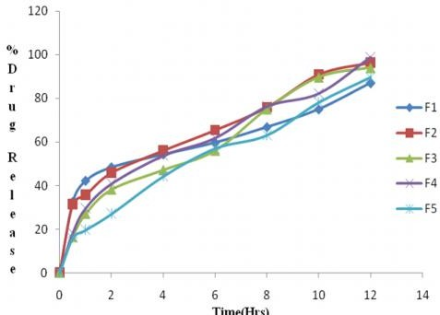

Fig. No. 01: Percentage cumulative drug release from formulations F1 to F5

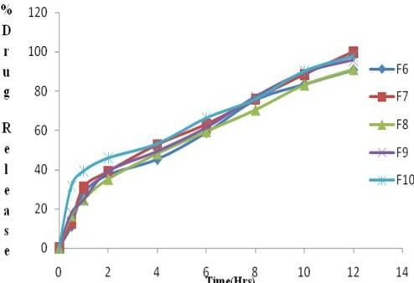
Fig. No. 02: Percentage cumulative drug release from the formulation F6 to F10

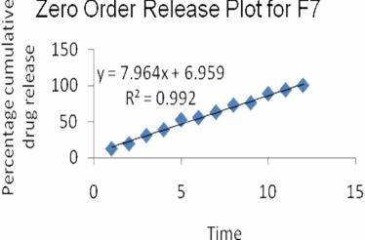
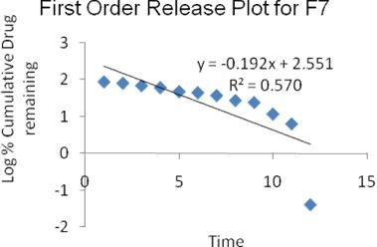

Fig. No. 03: Zero order release plot for F7 Fig. No. 04: First order release plot for F7
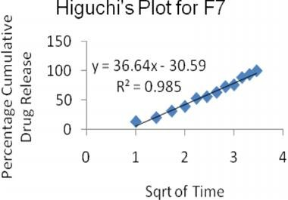
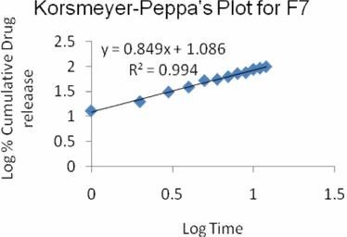
Fig. No. 05: Higuchi’s plot for F7 Fig. No. 06: Korsmeyer-peppa’s plot for F7

Conclusion
The primary aim of the research work was to develop a gastro retentive drug delivery system of ciprofloxacin with two types of swellable polymers. The drug is commonly used for H.pylori infection, infectious diarrhea and lower respiratory tract infections.

Gastro retentive drug delivery system of ciprofloxacin was developed in treating H.pylori infection. The developed formulation may increase the gastric residence time to release the drug in a steady state fashion. Various evaluation parameters were undergone to select ideal formulation F7 (Drug in combination with HPMC K15Mand sodium alginate in the ratio of 1:3 with calcium carbonate) met all the evaluation parameters and selected as the ideal formulation. From the results, the ideal formulation proved for its ability in delivering the drug in a controlled manner for the treatment of H.pylori infection.

Acknowledgement
The authors are very thankful to the Director and Principal of “The Dale View College Pharmacy and Research Centre”, Trivandrum, Kerala and Karpagam University, Coimbatore for their timely help and support in completion of the research work in a successful manner.

References
- Reynolds. J.E.F, Martindale. The Extra Pharmacopoeia, The Royal Pharmaceutical Society: London, 1996, 1218-1220.
- Singh.B; Kim,K.J.Control, Release, 2000, 63, 235-59.
- Indian pharmacopoeia, The Controller of Publications: Delhi,1996,Vol.II,734-736.
- Banker.G.S; Anderson.N.R. The Theory and Practice of Industrial Pharmacy, Varghese Publishing House: Bombay, 1987,297-299.
- Rosa.M;Zia.H; Rhodes.T. Int. J.Pharm., 1994, 65-70,105.

- Tripathi.K.D., Essentials of Medical Pharmacology, New Delhi, Jaypee Brothers Medical Publishing (p) Ltd. , 2003, 247.
7. T.Higuichi,J.Pharm.Sci., 52, 1145, 1963.
- R.W.Korsmeyer, R.Gurny, E.Doelkar, P.Buri and N.A.Peppas, Int.J.Pharm., 15, 25, 1983.
- Chowdary.K.P.R., Mahapatra.P and Murali Krishna. M.N.,Indian J.Pharma.Sci.,68, 461,2006.
- Robinson.J.R, and Lee V.H.L, Controlled Drug Delivery, fundamental and application. Marcel Dekker, New York , 2011; 301-375.
- Willard, Instrumental Method of Analysis, 7th edn:, CBS publishers and Distributors, New Delhi, 302-316.
- S.T. Prajapati.L.D. Patel, D.M.Patel, Gastric floating matrix Tablets; Design and Optimization using combination of polymers, acta Pharm. 58 (2008) 221-229.
- R.Garg, G.D.Gupta, Progress in controlled Gatroretentive delivery systems, Trop.J.Pharm.Res. 7(3) (2008) 23-29.
- S.hwang, H.Park,K,Park, Gastric Retentive drug Delivery Systems, Crit. Rev. Ther. DrugCarrier Syst. 15 (3) (1998), 243- 284
- Remington: The science and Practice of Pharmacy, 21st ed., Lippincott Williams & Wilkins,Philadelphia, 2005 (electronic version).
- R.A.Arza, C.S. Gonugunta, P.R.Veerareddy, Formulation and evaluation of swellable and floating gastroretentive ciprofloxacin in hydrochloride tablets, AAPS Pharm SciTech.10(1) (2009) 220-226.
- J.Varshosaz, N.Tavakoli, F.Roozbahini; Formulation and invitro Charecerization of Ciprofloxacin floating and Bio adhesive extended release tablets, Drug Deliv. 13 (4) (2006) 277-285.
- The British pharmacopoeia Commission, HMSO, London, 2007 (electronic version).

