70

Research Article

Available Online at: www.ijpir.com

International Journal of Pharmacy and Industrial Research

ISSN
Print 2231 – 3648
Online 2231 – 3656

DESIGN AND EVALUATION OF BILAYER TABLETS OF DOXOFYLLINE HCL AND MONTELUKAST SODIUM FOR THE TREATMENT OF ASTHMA

^{*1}Shajan A, ²Narayanan N, ³Reema N, ³Aiswarya G
¹Research Scholar, Karpagam University, Coimbatore, Tamilnadu, India - 641 021.
²Jaya College of Pharmacy, Thiruninravur, Chennai, Tamilnadu, India – 602 024.
³Shree Devi College of Pharmacy, Mangalore, Karnataka, India – 574 142.

Abstract
This research work describes the formulation of bilayer tablets of doxofylline HCl and montelukast sodium as sustained release (SR) and immediate release (IR) layer respectively. The aim was to reduce the dose and dosing frequency and thus improve patient compliance in the treatment of asthma. Hydrophilic polymers like hydroxypropyl methylcellulose (HPMC) K15M and carbopol 934P and polyvinyl pyrrolidone (PVP) K30 as binder were used to prepare the sustained release layer by wet granulation technique and crosscarmellose sodium was used as superdisintegrant in the formulation of immediate release layer. The tablets were evaluated for their hardness, friability, drug content, disintegration and dissolution. The dissolution study of SR layer revealed that an increasing concentration of polymers results in decreased doxofylline release. The optimized formulation showed an immediate complete release of montelukast sodium within 45 min and a sustained doxofylline HCl release upto 13 h. The stability study results also complied with the International Conference on Harmonization (ICH) guidelines. From this study it was concluded that the developed bilayer tablets can be an effective alternative dosage form for asthmatics.

Keywords: Bilayer tablets, Doxofylline HCl, Montelukast Sodium, Carbopol 934P, Cross carmellose sodium.

Introduction
In the last few decades, asthma has shown an increasing prevalence affecting children and young people¹. It involves both inflammation and bronchoconstriction and hence the treatment of asthma is aimed at reducing inflammation and bronchoconstriction. Both doxofylline and montelukast are orally active drugs of choice for the treatment of asthma². Doxofylline [7-(1, 3- dioxolan-2-ylmethyl) theophylline] is a methyl

xanthine bronchodilator lacking affinity for adenosine receptors with anti- bronchospastic properties³. The half life of the drug is 7.42 h⁴. Montelukast sodium (ML) is an orally active leucotriene receptor antagonist used for the treatment of asthma. It blocks the action of leukotriene D4 on the cysteinyl leukotriene receptor CysLT₁ in the lungs and bronchial tubes by binding to it. Its half life is 2.7 to 5.5 h⁵.

Author for Correspondence:
Shajan A,
Shree Devi College of Pharmacy, Mangalore, Karnataka, India – 574 142. E-mail: shajpharma@yahoo.co.in

71
Shajan A. et al., Int. J. Pharm & Ind. Res., Vol.–03 (01) 2013 [70 - 76]

Combination therapy has numerous advantages over monotherapy in various diseases requiring long term treatment as it reduces the dose and dosing frequency and thus improves patient compliance⁶. In the present work, attempts were made to formulate bilayer tablets containing immediate release layer of montelukast sodium and sustained release portion of doxofylline HCl as an alternative to the conventional monotherapy for the treatment of asthma.

Materials and Methods
Doxofylline HCl, Montelukast sodium, Aerosil, Carbopol 934P, HPMC K15M, Lactose, Microcrystalline cellulose phthalate PH 102, Magnesium stearate, PVP K30, Redoxide of iron, Starch, Talc were obtained from Burgeon Pharmaceuticals Pvt. Ltd., Chennai as gift sample and other excipients such as Crosscarmellose sodium, Hydroxy propyl cellulose were procured from Yarrow Chemicals Pvt. Ltd., Mumbai. All the reagents used in the present study were of analytical grade.

Drug- excipient compatibility studies
Fourier Transform Infrared (FTIR) spectroscopy FTIR spectra were recorded to check for the presence of any interaction between the drug and excipients used. Spectra were recorded for the physical mixture of doxofylline and excipients and montelukast and excipients using KBr pellet technique.

Preparation of doxofylline HCl sustained release (SR) layer
Doxofylline HCl was formulated as the SR layer. Five different trial batches were prepared by wet granulation technique using varying concentrations of polymers as shown in Table 1 (DF1-DF5). The drug and excipients were first passed through sieve no. # 80. PVP K30 (binder) was dissolved in isopropyl alcohol and added slowly to a blend of doxofylline HCl, lactose, HPMC K15M and carbopol 934P. Granules obtained were air dried and passed through sieve no. #20 and later blended with magnesium stearate^{7,8}.

Table No. 01: Composition per tablet of SR layer of doxofylline HCl (DF)
 | DF1 | DF2 | DF3 | DF4 | DF5
Doxofylline HCl | 400 | 400 | 400 | 400 | 400
Lactose | 100 | 130 | 120 | 114 | 109
HPMC K15M | 50 | 40 | 50 | 50 | 60
Carbopol 934P | 44 | 34 | 34 | 30 | 30
PVP K30 | 20 | 10 | 10 | 20 | 15
Magnesium stearate | 6 | 6 | 6 | 6 | 6
Isopropyl alcohol | 110 | 110 | 110 | 110 | 110

Ingredients Batch code (Quantity in mg)

HPMC- Hydroxy propyl methylcellulose; PVP - polyvinyl pyrrolidone

Table No. 02: Composition per tablet of IR layer of montelukast sodium (ML)
 | Quantity (mg)
Montelukast sodium* | 10.4
Hydroxy propyl cellulose | 4
Lactose | 50
Crosscarmellose sodium | 20
Aerosil | 2
Microcrystalline cellulose phthalate PH 102 | 175.6
Talc | 5
Magnesium stearate | 2.6
Redoxide of iron | 0.4

Ingredients Batch code – ML

*Overages added = 0.4 mg

Preparation of montelukast sodium immediate release (IR) layer
Based on our previously reported study, the composition of montelukast sodium IR granules
was finalized as given in Table 2⁹. All the ingredients were weighed and passed through sieve no. #40. Slugs were prepared containing hydroxy propyl cellulose, lactose and microcrystalline

72
Shajan A. et al., Int. J. Pharm & Ind. Res., Vol.–03 (01) 2013 [70 - 76]

cellulose phthalate PH 102 which were then passed through sieve no. # 20 to obtain granules. These granules were then blended with montelukast sodium, crosscarmellose sodium, aerosil, and redoxide of iron to get uniform blend. The above blend was then lubricated with talc and magnesium stearate.

Evaluation of granules
Prior to compression, granules were evaluated for their bulk density, tapped density, angle of repose, Hausner’s ratio and Carr’s index¹⁰.

Preparation of bilayer tablets
Five trial batches of bilayer tablets were prepared (DF1ML, DF2ML, DF3ML, DF4ML, DF5ML)
each tablet containing one layer of SR granules and the second layer of IR granules using 21 × 10 mm D Tooling oblong shape punch in a 27 station tablet compression machine (Cadmach, India). In the first step, the SR granules were fed into the die cavity and a pre-compression force was applied. To this, IR granules were then introduced and final compression was done fixing the hardness between 7.0-7.5 kg/cm².

Evaluation of tablets^{11,12}
The bilayer tablets were evaluated for the following parameters:

Thickness
The thickness of the bilayer tablets was measured using Digital Vernier Calipers. Five tablets from each batch were taken and the average thickness was expressed in millimeter.

Weight variation
Twenty tablets were randomly selected from each batch and weighed. Uniformity of weight and percentage deviation (as per IP limits) of individual weights from average weight was calculated.

Hardness and friability
Five tablets were taken and hardness was determined using Monsanto Hardness tester. The average hardness was calculated and expressed in kg/cm². Roche friabilator was used to determine the friability of the tablets. The % friability was calculated.

Assay
Twenty tablets were selected randomly and finely powdered. An amount equivalent to 400 mg
doxofylline HCl and 10 mg montelukast sodium was weighed accurately, transferred to a volumetric flask and mobile phase was added to it. The solution was then filtered through 0.45 μ filter paper and sonicated for 15 min. HPLC method was used for the analysis where 20 µl of the sample solution was injected into the system and the effluent was measured at 274 nm for doxofylline HCl and 347 nm for montelukast sodium.

Chromatographic conditions
Equipment: High Performance Liquid Chromatography
Column: Inertsil C18 (4.6 x 250 mm, 5 μm) Flow rate: 1.5 ml/min
Operating temperature: Ambient temperature Selected wave length: 274 nm for doxofylline HCl and 347 nm for montelukast sodium
Mobile phase ratio: Acetonitrile: Methanol: Ammonium acetate buffer (70:10:20 v/v, pH 5.5) Injection Volume: 20 μl
Run Time: 10 min

Disintegration test
The time at which the immediate release layer disintegrated was determined by disintegration apparatus using pH 1.2 buffer as the medium at 37
± 0.5 ˚C.

In vitro dissolution studies
In vitro drug release study was carried out using USP Type II apparatus (Electrolab USP-TDT-08L) at 37 ± 0.5˚C. Release of montelukast sodium was evaluated at 50 rpm using 1 % SLS as the medium. The samples were withdrawn at intervals of 15, 30 and 45 min and analyzed for montelukast content using HPLC (Shimadzu SPD-10 AVP) at 347 nm. Release of doxofylline HCl was carried out in a similar manner at 100 rpm upto 13 h using water as dissolution medium. The collected samples were analyzed at 274 nm using UV spectrophotometer (Shimadzu 1800).

Kinetic analysis of release data
The interpretation of the release profile was carried out using different kinetic models, namely, Zero order, Higuchi and Korsmeyer- Peppas ^{13,14}.

Stability studies
Bilayer tablets from the optimized batch were packed in air tight bottles and subjected to accelerated stability studies for 6 months at 40 ˚C ±
2 ˚C/ 75 % RH ± 5 % RH according to

73
Shajan A. et al., Int. J. Pharm & Ind. Res., Vol.–03 (01) 2013 [70 - 76]

International Conference on Harmonization (ICH) guidelines¹⁵. At intervals of 3 months and 6 months, sufficient number of tablets were taken and evaluated for their appearance, drug content, hardness and dissolution profile.

Results and Discussion

Drug excipient compatibility study
Presence of any incompatibility between drug and excipients/polymers can be predicted by FTIR study. The spectra clearly showed the absence of any possible interaction between the drugs and excipients which was confirmed by the presence of characteristic peaks (Fig. 1, 2).

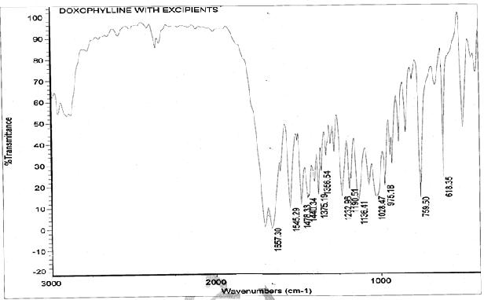

Fig. 01: FTIR graph for doxofylline
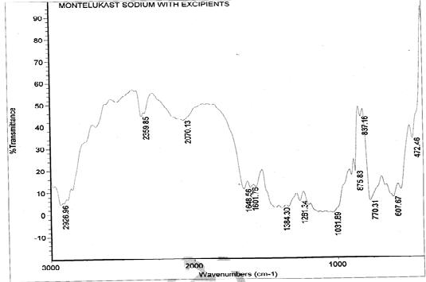
Fig. 02: FTIR graph for montelukast sodium

Table No. 03: Physical evaluation parameters of DF and ML granules

Bulk density
Batch code (g/ml) *
Tapped density (g/ml)* Hausner’s ratio* Carr’s index (%)* Angle of repose (˚)*

DF1 0.475 ± 0.004 0.551 ± 0.002 1.160 ± 0.005 13.778 ±0.392 23.00 ± 0.335
DF2 0.478 ± 0.001 0.544 ± 0.002 1.139 ± 0.007 12.239 ± 0.513 24.573 ± 0.620
DF3 0.479 ± 0.003 0.548 ± 0.002 1.144 ± 0.009 12.605 ± 0.667 23.457 ± 0.738
DF4 0.476 ± 0.004 0.545 ± 0.001 1.145 ±0.012 12.687 ± 0.902 24.117 ± 1.014
DF5 0.479 ± 0.001 0.554 ± 0.001 1.157 ± 0.004 13.562 ± 0.261 23.51 ± 0.780
ML 0.416 ± 0.003 0.501 ± 0.001 1.199 ± 0.006 16.578 ± 0.447 24.487 ± 0.641
*Values expressed as mean ± SD, n=3

74
Shajan A. et al., Int. J. Pharm & Ind. Res., Vol.–03 (01) 2013 [70 - 76]

Evaluation of granules
The granules from all the batches were evaluated for their angle of repose, bulk density, tapped density, hausner’s ratio and carr’s index. The bulk and tapped densities of the granules of DF varied only slightly among various batches of DF. For the ML granules, the bulk and tapped densities were found to be 0.416 ± 0.003 g/ml and 0.501 ±
0.001 g/ml respectively. The values indicated good packing character of both the granules. The Carr’s index for all the granules of DF was found to be < 15 % while that for ML granules was found to be
16.578 ± 0.447 %, indicating desirable flow properties. The angle of repose was found to be in the range of 23.00 ± 0.335˚ to 24.573 ± 0.620˚ which confirmed that the granules possessed good flow properties. The results are shown in Table 3.

Evaluation of bilayer tablets
The formulations were prepared under similar environmental conditions to avoid any changes in the final product. All the tablets were found to be free of cracks and had a smooth surface, capsule shaped with SR layer white in colour while IR layer was uniformly red in colour. The tablets were found to be uniform in thickness. The results of hardness and friability were within accepted limits which suggested that the tablets could withstand stress during transportation and packing. The maximum weight of the tablets was found to be
891.02 ± 2.041 mg and the deviation was within IP limits. The IR layer of the bilayer tablet disintegrated within 80 sec which may be due to the presence of superdisintegrant. The results are tabulated in Table 4.

Thickness

Table No. 04: Evaluation of tablets

Disintegration

Batch code
(mm)
* Hardness (kg/cm³)* Friability (%)* Weight variation (mg)
time (sec)** of IR layer

*average of three determinations; ** average of six determinations; values expressed as mean ± SD
DF1ML | 5.69 ± 0.007 | 7.1 ± 0.224 | 0.116 ± 0.002 | 890.44 ± 1.951 | 77.33 ± 2.25
DF2ML | 5.708 ± 0.04 | 7.3 ± 0.274 | 0.115 ± 0.003 | 890.09 ± 2.458 | 78.00 ± 1.897
DF3ML | 5.696 ±0.005 | 7.3 ± 0.274 | 0.115 ± 0.003 | 891.02 ± 2.041 | 79.00 ± 1.789
DF4ML | 5.714±0.009 | 7.1 ± 0.224 | 0.115 ± 0.002 | 890.15 ± 2.914 | 79.50 ± 1.517
DF5ML | 5.702±0.008 | 7.4 ± 0.223 | 0.118 ± 0.002 | 890.44 ± 2.291 | 78.67 ± 2.658

The drug content was found to be uniform in all the batches and in the range of 95 - 96 % in the batch
of ML and that in DF ranged between 96 - 98 % (Table 5).

Table No. 05: Assay of tablets
 | DF1ML | DF2ML | DF3ML | DF4ML | DF5ML
Doxofylline HCl (DF) | 97.89 | 96.45 | 97.35 | 98.05 | 98.36
Montelukast sodium (ML) | 95.68 | 97.28 | 95.23 | 95.87 | 96.30

Drug Amount of drug (%)

In vitro release study
The release of drug from IR layer was found to be
98.3 % at the end of 45 min due to the presence of superdisintegrants (Fig. 3). The SR layer of tablet DF1ML showed a release of 50 % at the end of 13 h whereas DF2ML gave a release of 95 % at 9 h. Both DF3ML and DF4ML showed a release of 99
% at the end of 10 h and 11 h respectively. Based on the study DF5ML released 98 % of the doxofylline at the end of 13 h. This change in the release may be attributed to the presence of

polymers. Slow release of drug from DF1ML may be attributed to higher amount of HPMC K15M and carbopol 934P present. Granulating agent further added to its slow release. Polymers retard the release by swelling and thus forming a gel like barrier around the tablet. In vitro study of the tablets revealed that the release of the drug from the SR layer depends on the concentration of polymers HPMC K15M and carbopol 934P and binder PVP K30 (Fig. 4).

75
Shajan A. et al., Int. J. Pharm & Ind. Res., Vol.–03 (01) 2013 [70 - 76]
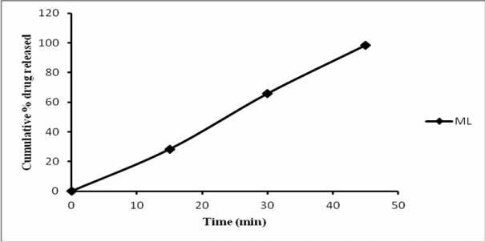

Fig. 03: In vitro release profile for montelukast sodium IR layer
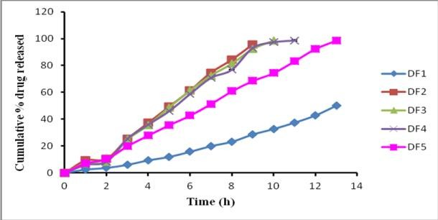
Fig. 04: In vitro release profile for doxofylline HCl SR layer

Release kinetics
The in vitro release of the best formulation of DF5 can be explained by zero order equation with R²=
0.998 and n value of the formulation showed that the mechanism of release was super case II transport (Table 6).

Table No. 06: Drug release kinetic data for doxofylline

Batch code Zero order
R2 |  | R2 | n R²
DF1 | 0.973 | 0.830 | 1.231 | 0.981
DF2 | 0.990 | 0.868 | 1.179 | 0.955
DF3 | 0.99 | 0.883 | 1.272 | 0.957
DF4 | 0.985 | 0.897 | 1.284 | 0.967
DF5 | 0.998 | 0.906 | 1.09 | 0.990

Higuchi model
Korsmeyer model

Table No. 07: Data for stability studies for optimized batch DF5ML
Parameters Time interval
Initial 3 months 6 months

Appearance ML layer- Red coloured
DF layer- White coloured
Hardness (kg/cm²)* 7.2 ± 0.274  Drug content (%)* | 7.26 ± 0.251 | 7.3 ± 0.274
ML 96.30 | 95.94 | 95.53
DF 98.23  In vitro release (%)* | 97.89 | 97.24
ML 93.23 ± 0.579 | 92.27 ± 0.345 | 91.31 ± 0.187
DF 97.79 ± 0.433 | 95.00 ± 0.483 | 97.79 ± 0.433

No change No change

(at the end of 45 min)

(at the end of 13 h)

*Values expressed as mean ± SD, n= 3

76
Shajan A. et al., Int. J. Pharm & Ind. Res., Vol.–03 (01) 2013 [70 - 76]

Stability studies
The results are shown in table 7. It was observed that the tablets showed no significant changes in the hardness, appearance and in vitro release under the specified conditions.

Conclusion
From the present research work it was observed that using a combination of polymers HPMC K15M and carbopol 934P, the release of the drug DF can be altered and a sustained effect could be obtained which can aid in dose reduction of the drug. Incorporation of superdisintegrant crosscarmellose sodium resulted in an immediate release of ML. Both these drugs combined as bilayer dosage form gave an immediate release followed by sustained release which can be used for an effective therapy for the long term therapy of asthma.

References
- Angeles MB, Castro JEM. Total control of asthma: an evaluation in patients of a tertiary hospital. Revista Alergia Mexico. 57(4), 2010,123-126.
- Walker R, Edwards C. Clinical Pharmacy and Therapeutics. Ed 3, Churchill Livingstone, Elsevier Limited, Spain, 2006, pp. 378-379.
- Cogo R, Castronuovo A. Effects of oral doxofylline on inflammatory changes and altered cell proliferation in chronic obstructive bronchitis. Eur Rev Med Pharmacol Sci. 4, 2000, 15-20.
- Dini FL and Cogo R. Doxofylline: A New Generation Xanthine Bronchodilator Devoid of Major Cardiovascular Adverse Effects. Curr Med Res Opin. 16(4), 2001, 258-268.
- Jones TR, Labelle M, Belley M, Champion E, Charette L, Evans J et al. Pharmacology of montelukast sodium (Singulair), a potent and selective leukotriene D₄ receptor antagonist. Can J Physiol Pharmacol. 73(2), 1995, 191-201.
- Haquea T, Talukderb MU, Fatemaa K, Rahmanc Z. Designing of fixed-dose combined tablets containing sustained- release portion of naproxen and immediate-release portion of ranitidine hydrochloride. Asian J Pharm Sci. 6 (3– 4), 2011, 109-122.
- Efentakis M, Peponaki C. Formulation study and evaluation of matrix and three- layer tablet sustained drug delivery systems based on carbopols with isosorbide mononitrate. AAPS PharmSciTech. 9(3), 2008, 917-923.
- Ramesh, Sathish Kumar D, Guruviah, Harani A. Formulation and evaluation of the bi-layered sustained release matrix tablets of metformin HCl SR and pioglitazone. Am Eurasian J Sci Res. 5(3), 2010, 176-182.
- Shajan A, Narayanan N. Formulation and evaluation of bilayer tablets of doxofylline HCl and montelukast sodium. Int J Adv Pharm. 2(2), 2012, 119-124.
- Sinko PJ. Martin’s Physical Pharmacy and Pharmaceutical Sciences. Ed 5, Lippincott Williams & Wilkins, 2006, pp. 553-559.
- Lachman L, Lieberman HA. The Theory and Practice of Industrial Pharmacy. Special Indian Ed, CBS Publishers and Distributors Pvt. Ltd, New Delhi, 2009, pp. 296-303.
- Indian Pharmacopoeia 2007. Indian Pharmacopoeia Commission, Ghaziabad, Vol 2, pp. 662-665.
- Higuchi T. Mechanism of sustained action medication. Theoretical analysis of rate release of solid drugs dispersed in solid matrices. J Pharm Sci. 52, 1963, 1145- 1149.
- Korsmeyer RW, Gurny R, Peppas NA. Mechanisms of solute release from porous hydrophilic polymers. Int J Pharm. 15(1), 1983, 25-35.
- International Conference on Harmonization, Q1A(R2), Harmonised Tripartite Guidelines, Stability testing of new drug substances and products, Geneva, February 2003.

