64

Research Article

Available Online at: www.ijpir.com

International Journal of Pharmacy and Industrial Research

ISSN
Print 2231 – 3648
Online 2231 – 3656

FORMULATION AND EVALUATION OF MOUTH DISSOLVING TABLETS OF NAPROXEN SODIUM

^{*,1}Vijaya Kumar Voleti, ¹Vedachalam Gunasekharan, ¹Sai Padmini Bolla
¹Mounica Rayaprolu, ¹Mohan Kumar Junju, ²Vaishnavi Voleti
¹RAO’s College of Pharmacy, Nellore, Andhra pradesh, India - 524 320.
²Sankar Reddy Institute of Pharmaceutical Sciences, Andhra pradesh, India - 523370.

Abstract
The present investigation deals with formulation of Naproxen sodium Mouth dissolving tablets using super disintegrants .Naproxen sodium is an analgesic and NSAID, used for the treatment of Pain and inflammation caused by condition such as osteoarthritis and rheumatoid arthritis .However, Gastric discomfort caused by Naproxen sodium results in poor patient compliance associated with its conventional dosage form. Hence the present study is carried out with the view to develop Mouth dissolving tablets of Naproxen sodium, which produces rapid onset of action and minimizes gastric discomfort associated with it. Thus improves patient Compliance, enhances bioavailability and also reduces the dose of drug. In this study MDTs are prepared by direct compression method using four different super disintegrants in different proportions .The powder blend is subjected to precompression evaluation parameters including bulk density, true density, tapped density, cars index, Hausner’s ratio and angle of repose. The formulations are evaluated for weight variation, hardness, wetting time, water absorption test, disintegration time and in vitro dissolution studies and all formulations complies its Pharmacopoeial standards. The tablets are evaluated and the results compared for all four super disintegrants revealed cross povidone to be the most efficacious super disintegrant to formulate mouth dissolving tablets of Naproxen sodium as suggested by the dispersion time, disintegration time and drug dissolution profiles.

Keywords: MDT, Naproxen Sodium, Crosscarmellose sodium, Sodium starch glycolate, Cross povidone.

Introduction
Naproxen sodium¹ is a Non steroidal anti inflammatory agent useful for the treatment of pain, inflammation and fever caused by the conditions such as arthritis, migraine and menstrual cramps. It has a good solubility in water and saliva and inherent ability to permeate through oral mucosal tissue. Drug moiety is weak acidic, so remains in partially non ionized form at oral p^{H}

which favors pregastric absorption. These parameters make the drug ideal candidate for MDT. These tablets display a fast and spontaneous de-aggregation in the mouth, soon after the contact with saliva. The active agent can thus rapidly dissolve in the saliva and be absorbed through whatever membrane it encounters, during deglutition, unless it is protected from pre-gastric

Author for Correspondence: Vijaya Kumar Voleti, RAO’s College of Pharmacy,
Nellore, Andhra pradesh, India - 524 320. E-mail: vijay66vvk@gmail.com

65
Vijaya Kumar Voleti. et al., Int. J. Pharm & Ind. Res., Vol.–03 (01) 2013 [64 - 69]

absorption. To fulfill these requirements, tablets must be highly porous, incorporating hydrophilic excipients, able to rapidly absorb water for a rapid deaggregation of the matrix. Different technological techniques, Such as freeze drying, moulding and direct compression are currently employed to prepare the formulations of this type present on the pharmaceutical market.
The following are the various Characteristics of fast disintegrating systems²
- Ease of administration
- Taste of the medicament
- Hygroscopicity
- Friability
- Mouth feel
Conventional dosage form of Naproxen sodium tablets are less advantageous due to bad taste and high first pass metabolism resulting in non compliance and ineffective therapy. The basic approach used in the development of MDT is the use of super disintegrants such as Crosscarmellose sodium, Sodium starch Glycolate and Cross povidone. Before that bitter taste of Naproxen sodium is masked by using sweetener. Thus the objective of present study is to develop MDT’s of Naproxen sodium and pregastric and gastric discomfort. The drug having half life of 12-24 h is well absorbed after oral administration, achieving peak plasma concentration (C_{max}) within 1 to 2 h after dosing³. It has good solubility in water and saliva and inherent ability to permeate through oral mucosal tissue. Drug moiety is weakly acidic, so remains in partially non ionized form at oral cavity’s pH, which favors its pregastric absorption. So, all the mentioned parameters make the drug ideal candidate for design of MDTs with regards to patient compliance by minimizing its side effects and rapidifying the action.

Experimental

Materials
Naproxen Sodium and super disintegrants were obtained as gift samples from Granules India Ltd & SD fine chemicals, Mumbai, India. Talc and magnesium stearate used for the preparation of tablets were of Pharmacopoeial grade.

Methods
Evaluation of flow properties of blend
The quality of tablet is generally dictated by the quality of physicochemical properties of blends. There are many formulation and process variables
involved in mixing step i.e micromeretic properties like bulk density, true density, Carr’s index, Hausner’s ratio and angle of repose can affect the characteristics of blends produced. Authentication of drug and drug excipient compatibility are carried out by IR and UV analysis.

Preparation of the tablet formulations by direct compression method
All the ingredients such as Naproxen sodium, superdisintegrants⁴ such as Crospovidone, crosscarmellose sodium & Sodium starch Glycolate (SSG) were weighed and passed through #60 meshes separately. Then the ingredients were mixed and compressed into tablet using 7mm flat faced punches on 16 station rotary tablet machine. Formulations of Naproxen sodium by direct compression method are shown in Table 1.

Evaluation of Formulated tablet Hardness
Compression forces required to break the tablet were measured.

Weight variation test⁵
20 tablets were taken and their weight was determined individually and collectively on a digital weighing balance. The average weight of one tablet was determined from the collective weight. The weight variation test would be a satisfactory method of determining the drug content uniformity.

Friability⁶
Roche friabilator was used to determine the friability. Pre weighed tablets are placed in Roche Friabilator and rotated at a speed of 25 rpm for 4minute or upto100 revolutions. The percentage friability of the tablets was measured as per the following formula,
(Winitial-Wfinal) Friability = 100
Winitial

Content uniformity
From each batch of prepared tablets, ten tablets were collected randomly and powdered. A quantity of powder equivalent to weight of one tablet was transferred in to a 100 ml volumetric flask, to this 50 ml of pH 6.8 buffer was added and then the solution was subjected to sonication for about 2 hrs. The solution was made up to the mark with

66
Vijaya Kumar Voleti. et al., Int. J. Pharm & Ind. Res., Vol.–03 (01) 2013 [64 - 69]

pH 6.8 buffer. The solution was filtered and suitable dilutions were prepared with pH 6.8 buffer. Same concentration of the standard solution was also prepared. The drug content was estimated by recording the absorbance at 272⁷ nm by using UV- Visible spectrophotometer.

Wetting time^{8,} ⁹
A sample of the final tablet was placed in Petri dish (10 cm in diameter) containing 10 ml water at room temperature. The wetting time is that necessary for the complete wetting of the tablet. Results of this test, carried out in triplicate, are shown in for the different samples.

Water absorption ratio¹⁰
A piece of tissue paper folded twice was placed in a small petri dish containing 6 ml of water. A tablet was put on the tissue paper and allowed to completely wet. The wetted tablet was then weighted. Water absorption ratio, R was determined using following equation.

R = (W_{a} - W_{b}) / W_{b} x100

Where W_{a} is the weight of tablet after water absorption and W_{b} is the weight of tablet before absorption.

In vitro dissolution
Freshly prepared phosphate buffer (pH 6.8) of 900 ml was placed in each dissolution vessels of dissolution test apparatus (USP, II paddle method). The tablets were placed in the dissolution medium. The temperature of the dissolution medium was maintained at 37± 0.5⁰C and the paddle was rotated at 50 rpm. Each time Five ml samples were withdrawn. The sample volume was immediately replaced with the same volume of fresh media as when a sample was taken. The samples withdrawn were filtered, diluted and estimated spectrophotometrically at 272 nm. Cumulative amount of the drug released at each interval was calculated by using standard graph of Naproxen sodium.

FTIR Study
In this study, FTIR spectra for the drug and the excipients of the optimized tablets were obtained. One part of Potassium Bromide was mixed with 100 parts of the optimized tablet powder and used for the FTIR spectrum. Pure drug was also mixed
with Potassium Bromide and spectrum was obtained. Both spectra were compared for possible deviations.

Results and discussion
MDTs of Naproxen sodium were prepared by using three super disintegrants in different proportions by direct compression method. The physical mixture was evaluated for their micromeritic properties like bulk density, true density, Carr’s index, Hausner’s ratio and angle of repose (Table-2). The data revealed that powder blend have good flow properties and packing abilities.

The hardness was found to be 3.0 kg/cm² to 4 kg/cm^{2,} percent friability was less than 1%, lies between 0.62-0.85% indicating sufficient mechanical integrity and strength of prepared tablets. The percent drug content was found to be lies between 99-100% which was within acceptable limits. Wetting time and water absorption ratios are measured as procedures described earlier. The value was found to be lie between 37-74 and 69-92 sec respectively. Disintegration time ranges from 32-60sec. Wetting time is closely related to inner structure of the tablet. Thus wetting process was very rapid in almost all formulations. The results were tabulated in Table 3.

All the formulations follows first order kinetics. Invitro dissolution studies revealed that F8 showed best drug release (97.32±1.24%) in 45sec and other batches showed less percentage of drug release than F8 showed in Fig 1.

Drug-Excipient compatibility studies are done by using IR studies. The drug samples showed characteristic functional group peaks at 1244 cm⁻¹ due to C-O stretching (acid) 1586.02 cm⁻¹ due to COO⁻ stretching , 1641.31 cm⁻¹ due to C-C aromatic skeletal stretching, 2835.16 cm⁻¹ due to C-H bond aliphatic stretch . IR characteristic mentioned for sample drug were found to be in compliance with that reported pure naproxen sodium. IR spectrum of drug – excipient showed characteristic functional group peaks as reported for naproxen sodium( Fig 2 & 3).

67
Vijaya Kumar Voleti. et al., Int. J. Pharm & Ind. Res., Vol.–03 (01) 2013 [64 - 69]

Table No. 01: Formulation of Naproxen sodium MDTs by Direct compression method (MD1- MD9)

Ingredients MD 1
mg
MD 2
mg
MD3 mg MD 4 mg MD5 mg MD6 mg MD 7 mg MD 8 mg MD9 mg

Drug 275 275 275 275 275 275 275 275 275
SSG 10 20 30 - - - - - -
CCS - - - 10 20 30 - - -
CP - - - - - - 10 20 30
Mannitol 109 99 89 109 99 89 109 99 89
Aspartame 2 2 2 2 2 2 2 2 2
Mg.stearate 2 2 2 2 2 2 2 2 2
Talc 2 2 2 2 2 2 2 2 2
Total weight 400 400 400 400 400 400 400 400 400

Table No. 02: Evaluation of Powder blend of drug and Excipients

Formula Angle of repose (θ) Bulk density
(gm/cm³)
Tapped density (gm/cm³)
Compressibility index (I) Hausner’s ratio

MD 1 27.6 0.38 0.52 15.72 0.9
MD 2 29.4 0.43 0.71 17.01 1.19
MD 3 26.3 0.36 0.62 15.93 1.2
MD 4 30.0 0.36 0.59 16.28 0.7
MD 5 26.8 0.4 0.62 16.31 1.15
MD 6 29.3 0.39 0.71 14.18 0.92
MD 7 29.7 0.42 0.58 17.01 0.8
MD 8 27.5 0.36 0.59 16.79 0.91
MD 9 28.4 0.42 0.61 17.68 1.2

Table No: 3 Evaluation of Naproxen sodium tablets

Formula
 |  |  |  |  | time (sec) |  | (sec) | ratio (%)
MD 1 | 3.5 | 400±1.15 | 0.75 | 4.17±0.05 | 47 | 49 | 73 | 69
MD 2 | 4 | 400±2.5. | 0.68 | 4.19±0.07 | 43 | 50 | 74 | 77
MD 3 | 3.2 | 400±1.5 | 0.64 | 4.16±0.05 | 49 | 55 | 70 | 81
MD 4 | 4 | 400±2.9 | 0.69 | 4.15±0.06 | 60 | 50 | 68 | 73
MD 5 | 3.1 | 400±1.9 | 0.73 | 4.14±0.09 | 55 | 59 | 62 | 75
MD 6 | 3.5 | 400±1.6 | 0.75 | 4.15±0.07 | 50 | 57 | 65 | 73
MD 7 | 3.1 | 400±1.5 | 0.79 | 4.17±0.05 | 40 | 47 | 41 | 70
MD 8 | 3.0 | 400±1.13 | 0.62 | 4.13±0.07 | 32 | 40 | 37 | 92
MD 9 | 3.5 | 400±3.1 | 0.85 | 4.16±0.05 | 38 | 49 | 45 | 81

Hardness (kg/cm²)
Weight variation
Friability Thickness (%)
In vitro Disintegration
Dispersion time (sec)
Wetting time
Water absorption

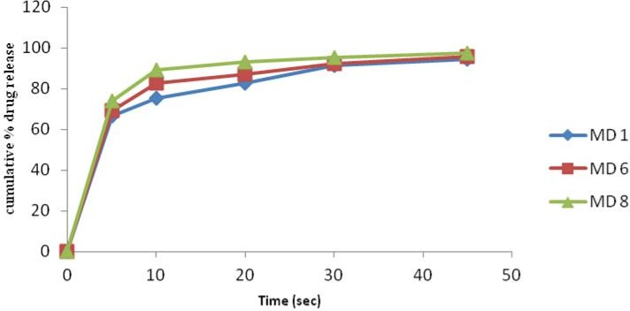

Fig. 01: Comparison of dissolution of F1, F6, F8 batches.

68
Vijaya Kumar Voleti. et al., Int. J. Pharm & Ind. Res., Vol.–03 (01) 2013 [64 - 69]

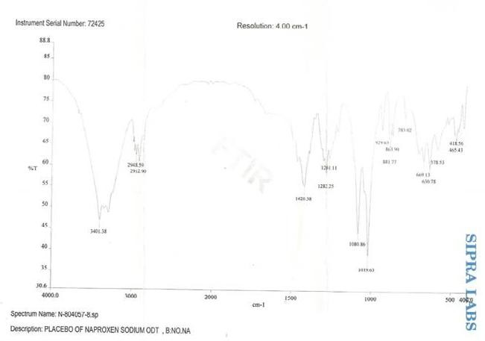

Fig. 02: FT-IR studies on Naproxen Sodium

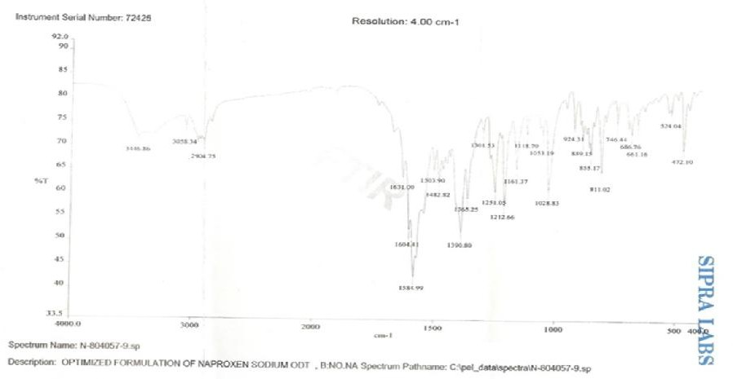
Fig. 03: FTIR Studies on optimized formulation of Naproxen Sodium ODT

Conclusion
MDTs of Naproxen sodium were prepared by direct compression method using three different super disintegrants. The tablets disintegrated rapidly in oral cavity and had appreciable hardness and friability. Invitro drug release from the tablets show significantly improved drug dissolution. Hence it was concluded that super disintegrant based mouth dissolution tablets of Naproxen sodium would provide quick onset of action without need of water for swallowing (or)
administration. Further investigations are needed to confirm the in vivo- efficiency.

Acknowledgements
Author expresses their sincere thanks to the head of the department of pharmaceutics and principal, Rao’s College of pharmacy, Nellore for the facilities provided. The author also expresses sincere thanks to Granules India Ltd, Hyderabad for their generous gift sample of drug and polymers.

References
69
Vijaya Kumar Voleti. et al., Int. J. Pharm & Ind. Res., Vol.–03 (01) 2013 [64 - 69]

- Neha vishal et al “Formulation and evaluation of Orodispersible tablets of Naproxen sodium”
. IJPSR, 2011- Vol 2 (II) -2983-2990.
- Bhaskaran S. Narmada G.V. Indian Pharmacist. 2002; 1, 9-12.
- Tripathi KD. Essentials of Medical Pharmacology. Jaypee Brothers Medical Publishers, New Delhi, Edition 5, 2003: 177.
- D. Bhowmik et al., ( 2009)., Fast Dissolving Tablet: An Overview; Journal of Chemical and Pharmaceutical Research.,163-177.
- Adamo Fini , Valentina Bergamante , Gian Carlo Ceschel , Celestino Ronchi , Carlos Alberto Fonseca de Moraes. Fast dispersible/slow releasing ibuprofen tablets. Eur J Pharm sci . 2008;69:335–341.
- Marshall K, Lachman N, Liberman HA. The theory and practice of industrial pharmacy.
3 ^{rd} ed. Mumbai: Varghese Publishing House; 1987. p. 66-9.
- Zade PS, Kawtikwar PS, Sakarkar DM. Formulation, evaluation and optimization of fast dissolving tablet containing tizanidine hydrochloride. Int J Pharma Tech Research 2009; 1: 34-42.
- Shaikh S et al., Formulation and evaluation of orodispersible tablets of piroxicam.,IJPI’s Journal of Pharmaceutics and Cosmetology, 2010, 2-8.
- Mahaveer Pr. Khinchi, Orally disintegrating tablets: A future prospectus., Int J Pharm Sci Bio.,2010, 71-79.
- Sunada H, Bi Y. Preparation, evaluation and optimization of rapidly disintegrating tablets. Powder Technology. 2002; 122: 188–198. doi:10.1016/S0032-5910(01)00415-6.

