Research Article

Available Online at: www.ijpir.com

International Journal of Pharmacy and Industrial Research

ISSN
Print 2231 – 3648
Online 2231 – 3656

DEVELOPMENT AND VALIDATION OF UPLC METHOD FOR SIMULTANEOUS ESTIMATION OF SITAGLIPTIN AND SIMVASTATIN FROM ITS PHARMACEUTICAL DOSAGE FORM

*¹ Kavitha K Y, ¹ Geetha G, ¹Hariprasad R, ²Venkatnarayana R, ¹Kaviarasu M
*¹ PSG College of Pharmacy, Peelamedu, Coimbatore, Tamilnadu, India - 641 004.
² R.V.S. College of Pharmaceutical Sciences, Sulur, Coimbatore, Tamilnadu, India - 641 402.

Abstract
A modified simple, selective, rapid, precise reversed phase ultra performance liquid chromatography method has been developed and validated for the simultaneous estimation of sitagliptin and simvastatin. The method was carried out on Waters Acquity BEH C18, 50×2.1 mm, 1.7 μm UPLC column with a mobile phase consisting of water : acetonitrile (30:70) adjusted to pH 4.0 with orthophosphoric acid. The flow rate was 0.35 ml/min and the effluent was monitored at 236 nm . The validation of the proposed method was also carried out in terms of linearity, accuracy, precision, symmetry factor, plate count, regression, and recovery. In conclusion this method can be used for routine quality control analysis due to its simplicity and accuracy.

Keywords: UPLC, Sitagliptin, Simvastatin, Validation, Method development.

Introduction
Sitagliptin (STG), [(2R)-1-(2,4,5-trifluorophenyl)- 4- oxo-4-[3-(trifluoromethyl)- 5,6 dihydro [1,2,4] triazolo [4,3-a]pyrazin-7(8H)-yl] butan-2-amine] (Fig 1) is a well knownhypoglycemic drug. STG is a novel oral hypoglycemic drug of the dipeptidyl
peptidase 4 inhibitor class1. Sitagliptin increased incretin levels (GLP-1 and GIP) which inhibit glucagon release, in turn decreases blood glucose, but more significantly increases insulin
secretion2.The determination of STG has been carried out in tablet by RP-HPLC by UV Spectrophotomerty3, RP-HPLC4 ,UPLC5, Laser diode thermal desorption tendem mass
spectrometry6, capillary electrophoresis7 Simvastatin (SMV), a methylated analog of

lovastatin, is -(+)-{1S,3R,7S,8S,8aR)-1, 2, 3, 7, 8,
8a-hexahydro-3,7-dimethyl-8-[2-(2R,4R)-tetra hydro -4-hydroxy-6-oxo-2H-pyran-2-yl]- naphthyl- 2,2-dimethyl butanoate (Fig 1). It acts by inhibiting HMG CoA reductase and is used for the treatment of hypercholesterolemia. After oral administration, this prodrug is converted into β hydroxy acid of simvastatin, which is a potent inhibitor of HMG CoA reductase, a key enzyme required for the
synthesis of cholesterol in liver2. The determination of Simvastatin has been carried out in tablets by
UV-Spectrophotometry 8-14,RP-HPLC15,16, HPLC17,
HPTLC17. A literature review reveals that various analytical method but there is unavailable for the simultaneous estimation of Sitagliptin and

Author for Correspondence:
Kavitha K Y,
PSG College of Pharmacy,
Peelamedu, Coimbatore, Tamilnadu, India – 641 004. E-mail: kaviky1978@rediffmail.com

Simvastatin in tablet dosage form in pharmaceutical preparations by UPLC. The objective of the present work is to develop and validate new analytical methods for simultaneous determination of Sitagliptin and Simvastatin in
tablet dosage form. This communication forms the first report of a simple, sensitive and reproducible method for the simultaneous estimation of Sitagliptin and Simvastatin from combined dosage form.

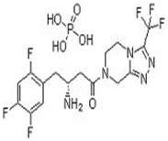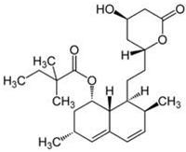
Sitagliptin Simvastatin

Fig. No. 01: Chemical structure

Experimental Materials and methods Instrumentation
The high pressure liquid chromatographic (HPLC) system used was of model SHIMADZU LC-10AD SPDM 10A Binary Gradient System equipped with Rheodyne injector and PDA detector controlled by LC solutions (version 1.25) software. A column Enable C-₁₈ G Column (250mmx 4.6mm, 5μm) was used as a stationary phase.UV-Visible spectrophotometer used was Shimadzu, Model- 1650. The UPLC instrument used was waters Acquity system. Empower Software was used for data acquisition. A Sartorius analytical micro balance, an ultra soniccleancer, pH meter L1610ELICO, micropipettes and micro-pore filtration assembly etc were also used.

Materials
Sitagliptin phosphateand Simvastatin API were got from well reputed pharmaceuticals.Methanol of analytical grade, distilled water Ammonium di hydrogen orthophosphate, Acetonitrile and water (HPLC grade) and ortho phosphoric acid (GR grade) were purchased from the market.

Methods Analytical Chromatographic condition
The chromatographic separation was achieved on a C₁₈ column (2.1 x50mm, 1.7μm particle size). The mobile phase was consisted of water and acetonitrile in the ratio of 30:70 (v/v) pH 4.0 adjusted with 0.1% orthophosphoric acid. The mobile phase was filtered through a 0.22 µm membrane filter before and degassed in an ultrasonic bath. The flow rate of mobile phase was

adjusted to 0.35ml/min and the injection volume was 5µl. Detection was performed at 236 nm.

Standard and sample preparation
Standard stock solution were prepared by dissolving 100mg of sitagliptin and 10mg of simvastatin in 100ml of mobile phase and 4 ml of the above solution was further diluted to 100ml with the same mobile phase to get a concentration of 40µg/ml and 4µg/ml for sitagliptin and simvastatin respectively.

Twenty tablets were weighed and crushed. The powder equivalent to 100mg of sitagliptin and 10 mg of simvastatin was accurately weighed and transferred into clean, dry 100ml volumetric flask. The powder was first dissolved in few ml of mobile phase through a whatmann filter to obtain the concentration 1000µg/ml and 100µg/ml for sitagliptin and simvastatin respectively. From the above stock solution , 4ml were transferred in to a 100ml volumetric flask and volume made upto 100ml with the mobile phase to get the concentration of 100μg/ml for sitagliptin 10μg/ml for simvastatin respectively. The standard and sample solutions were filtered through a membrane filter.

Selection of Wavelength
The wavelength of maximum absorption for sitagliptin is 248nm and simvastatin is 230nm. A single wavelength 236nm has been selected for estimation of sitagliptin and simvastatin as both the peaks have the significant response. Overlay spectrum of sitagliptin and simvastatin in Fig 2.

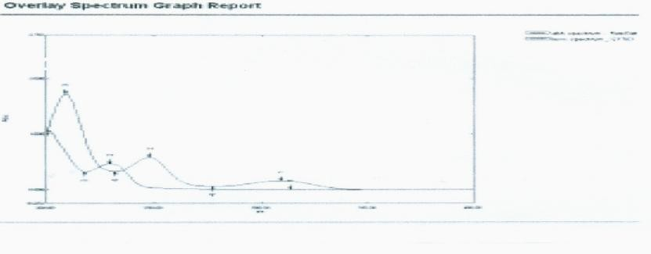

Fig. No. 02: Overlay Spectrum of Sitagliptin and Simvastatin

Results and discussion Method development Development trial-1:
When chromatography was carried out at room temperature on a 250 × 4.6 mm i.d., 5μm Phenomenex Gemini C18 column with the isocratic mobile phase of acetonitrile and water (70:30 v/v) pH adjusted to 2.5 at a flow rate of 1.0 ml/min, but poor resolution between sitagliptin and simvastatin were observed .

Development trial-2:
When chromatography was carried out at ambient temperature on a 250 × 4.6 mm i.d., 5μm Phenomenex Gemini C18 column with the isocratic mobile phase of acetonitrile and water (70:30 v/v, pH 3.5) at a flow rate of 1.0 ml/min, late elution and poor resolution between sitagliptin and simvastatin were found.

Development trial-3:
When chromatography was carried out at ambient temperature on a 250 × 4.6 mm i.d., 5μm Phenomenex Gemini C18 column with the isocratic mobile phase of acetonitrile and water (70:30 v/v, pH 4.0) at a flow rate of 1.0 ml/min, a satisfactory separation of the two drugs was achieved with good resolution and minimal tailing.

Method transfer on UPLC:
Our aim was to develop a rapid, sensitive, simple and reliable UPLC method which can be estimated for two components in less than five minutes. Hence, the above method was transferred on UPLC system using column selection chart and calculator. A satisfactory separation of the two drugs was achieved on a Acquity BEH C18 (50 x
2.1 mm,1.7 µm)column with a mobile phase of acetonitrile and water (70:30 v/v, pH 4.0) at a flow rate of 0.35 ml/min. Quantification was achieved with PDA detection at 236nm based on the peak area. Better resolution of the peaks with clear base line separation was found. The sitagliptin and simvastatin were eluted at 0.82 min and 1.80min respectively.

Validation parameters^{18,19}
The UPLC method was validated in terms of accuracy, precision, LOD, LOQ, linearity, range and robustness as per ICH guidelines.

Linearity
Five standard calibration solutions of sitagliptin and simvastatin having concentration in the range of 40-400μg/ml and 10-50μg/ml respectively were prepared by diluting the stock I solution with mobile phase. (Table 1 & Fig 2&3)

Table No. 01: Linearity data for SITA and SIM
Linearity(n=5) | Sitagliptin | Simvastatin
Range (μg/ml) | 40-400 | 10-50
Mean r2 value | 0.987 | 0.992
Regression quation | Y=280.0+4155 | Y=141.4- 4.214

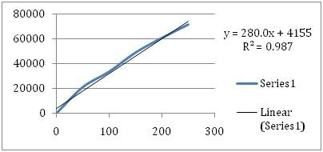
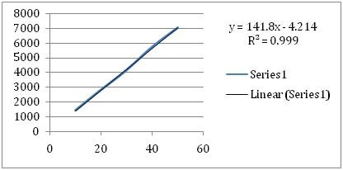
Fig. No. 02: Linearity curve for sitagliptin

Fig. No. 03: Linearity curve for simvastatin

System Suitability Tests
System suitability was verified by injecting working standard solution of 30μg/ml of sitagliptine and 2μg/ml of simvastatin. Various
parameters such as HETP, number of theoretical plates, tailing factor and resolution between the peaks of sitagliptin and simvastatin were obtained. (Table 2)

Table No. 02: System Suitability Data of STG and SMV
Parameters | Sitagliptin | Simvastatin
Retention time | 0.82 | 1.80
Repeatability % RSD | 0.09 | 0.05
Asymmetry | 1.37 | 1.26
Theoretical plates | 2100.93 | 4749.61
Resolution | - | 4.50

Accuracy
This parameter is performed to determine the closeness of test results with that of the true value which is expressed as % recovery. These studies

were performed at three different levels (50%, 100% and 150%) and the %recovery of sitagliptin and simvastatin was calculated. (Table 3)

Table No. 03: Recovery data of SITA and SIM
Component | Levels | Mean recovery | ±SD | %RSD
Sitagliptin | L1 | 103.42% | 0.54 | 0.52
 | L2 | 101.78% | 0.46 | 0.45
 | L3 | 103.27% | 0.51 | 0.49
Simvastatin | L1 | 103.71% | 048 | 0.46
 | L2 | 99.75% | 0.50 | 0.50
 | L3 | 101.8% | 0.42 | 0.42

Precision
The precision of the proposed method was evaluated by carrying out six independent assays of test sample. RSD (%) of six assay values obtained

was calculated. The intermediate precision was carried out by analyzing the sample in different days. (Table 4)

Table No. 04: Intermediate precision data of STG and SMV Compound
 | % of Label | % RSD | %of Label | % RSD
Sitagliptin | 100.18 | 0.57 | 9.940 | 0.69
Simvastatin | 10.06 | 0.59 | 10.8 | 0.6

Compound(n=6) Intra-day Precision Inter-day Precision

Specificity
Specificity of the method was evaluated by injecting the blank, working standard and stressed
samples into the chromatograph to check the co- elution, if any, at the retention time of sitagliptin peak and simvastatin peak (Fig 4).

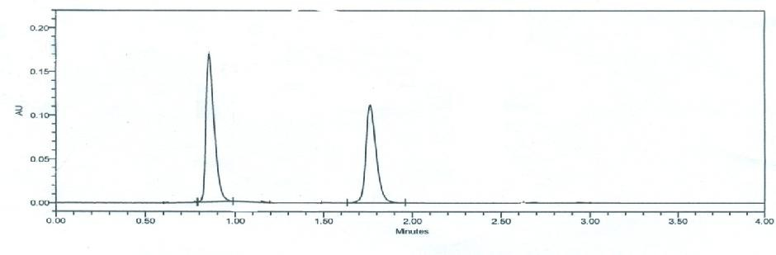

Fig. No 04: Typical chromatogram of standard mixture of sitagliptin(0.82 min) and simvastatin(1.80min)

Limit of Detection and Limit of Quantitation The limit of detection (LOD) and the limit of quantitation (LOQ) for sitagliptin and simvastatin

were determined from standard deviation of the response and the slope.

LOD= σ/S X 3.3 , LOQ = σ/S X 10 for the component sitagliptin and simvastatin (Table 5)

Robustness
Table No. 05: LOD, LOQ data for sitagliptin and simvastatin

Component LOQ(mcg/ml) LOD(mcg/mg)
Sitagliptin 0.94 0.312
Simvastatin 1.01 0.333

The robustness of the method was determined as a measure of the analytical method capability to be unaffected by small variations in method parameters. The different variations such as variation in flow rate by ± 0.2 ml/minute, variation
in wavelength by ± 2 nm. At these changed conditions, the standard solutions were injected. The amounts of sitagluptin and simvastatin were calculated (% assay) in each varied condition. (Table6)

Table No. 06: Robustness data of sitagliptin and simvastatin

Factor Level STG (n=3), Mean % assay
(% RSD)
SMV(n=3), Mean % assay (% RSD)

Flow rate | 0.9ml/min | 98.66%(0.92%) | 99.18% (0.83%)
 | 1.1ml/min | 99.09% (0.95%) | 99.78% (0.94%)
Wave length | 230nm. | 99.2% (1.11%) | 99.02% (0.92%)
 | 240nm. | 98.94% (0.95%) | 99.34% (0.91%)

Ruggedness
To test the ruggedness of the method, the analysis was done on different days and different chemists to check for any changes in the chromatograph. The percentage RSD for the retention time and area

was calculated.Data acquired and compared, % RSD of area and Rt has been calculated and tabulated in Table 7. Based on the data, it is evident that the method is Rugged.

Table No. 07: RSD of the drugs on different days and different analysts.

Day Analyst Component Rt
 | %RSD
1 1 Emtricitabine | 0.07 | 0.02 | 0.05
Tenofovir | 0.09 | 0.04 | 0.07
2 2 Emtricitabine | 0.06 | 0.04 | 0.08
Tenofovir | 0.05 | 0.09 | 0.03

Stand. area % RSD Sample area %RSD

Performance of the Drug/Batch Analysis
One market sample have been analysed to see the performance of the method. Tablet taken was

Juvisync which contains 100 mg sitagliptin and 10 mg of simvastatin. Results obtained have been summarized in the Table 8.

Juvisync

Table No. 08: Analysis of formulation
Drug Labelled amount(mg) Amount found %amount
Sitagliptin 100 100.55 100.55
Simvastatin 10 9.97 99.7

Stability of sample solution
Solution stability of two drugs solution in a tightly capped volumetric flask for 72 hr when stored ina refrigerator between 2 to 8 °C temperatures was studied. The content of drugs were determined in
24 hr intervals. The content of drugs were determined in the test solutions. No significant

changes were observed in the content of sitagliptine and simvastatine. The results from solution stability experiments confirmed that sample solution was stable up to 72 hr at 2-8°C temperature and did not show any appreciable change in sample area. (Table 9)

Table No. 09: Solution stability results
Time interval simvastatine Sitagliptine
% assay initial 100.55 99.70
% assay after 24 hr 99.98 99.82
% assay after 48 hr 100.54 100.00
% assay after 72 hr 100.08 99.93

Conclusion
A simple, precise and accurate method was developed for the quantitative estimation of sitagliptin and simvastatin in bulk drug and marketed formulation without any interference from the excipients. It is highly specific and pricise analytical procedure and chromatographic run time of five minutes allows the analysis of a large
number of samples in a short time period of time. The method validation shows satisfactory data for all the method parameters tested. Therefore this UPLC method can be used as a routine sample analysis.

Reference
- RamziaI.El-Bagary,EhabF.Elkady, Bassam M. Ayoub. Spectroflourometric and Spectrophotometric Methods for the Determination of Sitagliptin in Binary Mixture with Metformin and Ternary Mixture with Metformin and Sitagliptin Alkaline Degradation Product. International Journal of Biomedical Science 2011; 7(1), 62-69.
- RP Dixit, CR Barhate, SG Padhye, CL Viswanathan, MS Nagarsenker.Stability indicating RP-HPLC method for simultaneous determination of simvastatin and ezetimibe from tablet dosage form. Indian Journal of Pharmaceutical Sciences; 2010, 72(2), 204- 210.
- Ghazala Khan, Dinesh Sahu, Y. P. Agrawal, NeetuSabarwal, Avnish Jain and A. K. Gupta*, Simultaneous Estimation of Metformin and Sitagliptin In Tablet Dosage Form; Asian Journal of Biochemical and Pharmaceutical Research 2011;( 1)2, 2011.
- Shyamala.M*, Mohideen.S, Satyanarayana .T, Ch.NarasimhaRaju, Suresh Kumar.P, Swetha.K .Validated RP-HPLC for Simultaneous Estimation of Sitagliptin Phosphate and Metformin Hydrochloride in Tablet Dosage Form, American Journal of PharmaTech Research.;2012(1), 2249-3387.
- Chellu S. N. Malleswararao*, Mulukutla V. Suryanarayana 1, khaggamukkanti, Simultaneous Determination of Sitagliptin Phosphate Monohydrate and Metformin Hydrochloride in Tablets by a Validated UPLC method, ScientiaPharmaceutica, Sci Pharm. 2010;80(10;139-152.
- John G. Swale. Simultaneous quantitation of metformin and sitagliptin from mouse and human dried blood spots using laser diode thermal desorption tandem mass spectrometry, Journal of Pharmaceutical and Biomedical Analysis, 2011 june 55( 3), 544-551.
- TamasSohajda,WenHui Hu, Li sLiZeng, Houg Li, LajosSzente, BelaNoszal, SzabolcsBeni, Evaluation of the interaction between sitagliptin and cyclodextrin derivatives by capillary electrophoresis and nuclear magnetic resonance spectroscopy, Wiley online Library, 2011; 32(19):2648-54.
- Srivastava B., Akhtar J. and Baghel U.S.*, Simultaneous estimation of ezetimibe and simvastatin by Vierodt’s method, International

Journal of Pharmacy & Life Sciences, 1(2):105-108.
- P Bonde, S Sharma, N Kourav, A Attar, Development And Validated UV Spectrophotometric And RP-HPLC Methods For The Estimation Of Simvastatin And Ezetimibe In Combined Pharmaceutical Dosage For, Inter J Curr Trends Sci Tech2010; 1(3): 135–142.
- Nilesh Jain*, Ruchi Jain, Hemant Swami and Deepak Kumar Jain, RP-HPLC Method for Simultaneous Estimation of Simvastatin and Ezetimibe in Bulk Drug and its Combined Dosage Form, Asian J. Research Chem July- Sept. 2008. 1(1).
- S Balaji And A Sunitha*, Development And Validation Of Spectrophotometric Method For Simultaneous Determination Of Simvastatin And Ezetimibe In Tablet Formulations, Pak. J. Pharm. Sci October 2010; .23(4),375-378.
- N. M. Bhatia*, D. D. Deshmukh, S. U. Kokil and M. S. Bhatia, Simultaneous Spectrophotometric Estimation of Simvastatin and Ezetimibe in Tablet Formulation.Indian J PharmSci 2006; 5(3)68-69.
- VineetSingla, RadhikaBhaskar* and Rahul Bhaskar, Simultaneous Estimation of Simvastatin and Metformin Hydrochloride in Bulk and Solid Dosage Forms, http://www.rasayanjournal.com, Vol.3, No.3 (2010), 507-513, ISSN: 0974-1496.
- VarshaBalkrishna Mane*, Surekha Babar, Nita Kulkarni., Development of UV Spectrophotometric method for the simultaneous estimation of Simvastatin and Ezetimibe in tablet dosage form by simultaneous Equation and Absorbance ratio method., International Journal of PharmaTech Research Coden (USA): IJPRIF ISSN : 0974- 4304, Vol.3, No.3, pp 1459-1466, July-Sept 2011.
- MujeeburRahman*, GazalaParveen, N.K.Nyola, Shahroz Khan, SushmaTalegaonkar, M. Shaharyar and R.K.Khar. Simultaneous Estimation of Simvastatin and Ezetimibe in Pharmaceutical Tablet Dosage Forms by RP-HPLC: a review. International Journal of Pharma Research and Development – Online, Publication Ref No.: PRD/2010/Pub/Arti/Vov-2/Issue-9/Nov/008.

- Chaudhari BG, Patel NM, Shah PB. Stability- indicating reversed-phase liquid chromatographic method for simultaneous determination of simvastatin and ezetimibe from their combination drug products, JAOAC Int. 2007;20(9), 789-790.
- B.StephenRathinaraj,* V.Rajamanickam, P.Joseph Mazarin Fiedlis, A. L. AshikElahi, Ch.Rajveer, D.Kumaraswamy, Development and validation of analytical methods for simultaneous estimation of simvastatin and ezetimibe in combined dosage form. Journal of Advanced Pharmaceutical Research 2010, 1(2), 133-139.
- ICH, “Validation of Analytical Procedures: Text and Methodology,” International Conference on Harmonisa-tion Guidance Documents, Q2(R1), 2005.
- ICH, Stability Testing, Q1A (R2), Stability Testing of New Drug Substances and Products. Feb 2003; 1-20.

