Ashwini Vastrad. et al., Vol.–05 (02) 2015, 136 – 140.

136

***Research Article***

**Available Online at:** [**www.ijpir.com**](http://www.ijpir.com/)

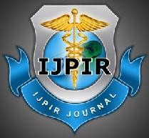

International Journal of Pharmacy and Industrial Research

**ISSN**

**Print 2231 – 3648**

**Online 2231 – 3656**

**AN ETHNOBOTONICAL STUDY OF MEDICINAL PLANTS IN HAVERI DISTRICT OF KARNATAKA, INDIA WITH SPECIAL REFERENCE**

**TO BANK OF VARADA RIVER**

# *1Ashwini Vastrad, 2Lalitha B R

1S S Ayurvedic Medical College, Haveri, Karnataka, India.

# 2Post graduate Department of Dravyaguna, GAMC, Banglore, Karnataka, India.

## Abstract

The present paper deals with the folklore herbs used in the traditional practices in the area of villages over the bank of Varada river of Haveri district, Karnataka, India to cure various ailments. Now the modern world is realizing the importance of folklore practice and these practitioners do have valuable information about the medicinal plants and their uses since from generations for the cure of many diseases. This survey was carried out during 2009-2010 in view of documenting traditional knowledge as Haveri district is an under explored area having mixed vegetation and is blessed with rich diversity of herbal medicinal plants and well known for the traditional practices for fractures, skin disorders, nervine disorders etc. In an ethno-botanical exploration of this area traditional practitioners were documented for the identification of the plants, local name, parts used, method of preparation of the medicine, mode of administration, duration, and their parameters for the diagnosis of different diseases. During the ethno-medical documentation it was found that totally 68 different plants are used in treating 34 different disorders by 33 folklore practitioners. Among them it was revealed that 19 therapeutic remedies are having classical references in Ayurveda like use of *Abrus precatorius Linn* in skin disorders, *Plumbago zeylanica Linn* in piles, *Mimosa pudica* in uterine disorders, *Cissus quadrangularis Linn* in fractures etc and the rest are considered as anubhuta prayoga. Further research is needed to conserve and develop some selected species of folklore herbs and to preserve the knowledge of indigenous communities.

**Keywords:** Ailments, Varada river, Anubhuta prayoga.

## Introduction

India is a vast country that has tropical weather with variations from region to region. India possesses unique geology and geography, which has influenced the climate and weather of the country.1 Ethnobotony is the scientific study of the way plants and animals are treated or used by different human cultures. It studies the dynamic relationships between peoples, biota, and environments, from the distant past to the

immediate present.2 Haveri is exactly situated in the centre of Karnataka and is blessed with both wet and dry climate resulting rich diversity of medicinal plants. Since from the British period Haveri district is popular for its traditional practices in treating various ailments.Varada river is one among the important water source of Haveri district covering the four major taluks Hangal, Haveri, Shiggaov and Savanur.3,4 Varada consists of 64

### Author for Correspondence:

Ashwini Vastrad,

### E.mail: [ashwini.haveri@gmail.com](mailto:ashwini.haveri@gmail.com)

Ashwini Vastrad. et al., Int. J. Pharm & Ind. Res., Vol.–05 (02) 2015 [136 - 140]

137

villages over its river bank with rich medicinal plant source. Hence a research work was taken up to conduct ethno botanical study in Haveri district with special reference to bank of Varada river.

## Materials and Methods

* Study area is located in the centre of Karnataka situated between 14.28 &14.59 latitudes and

75.07 &75.38 longitudes.

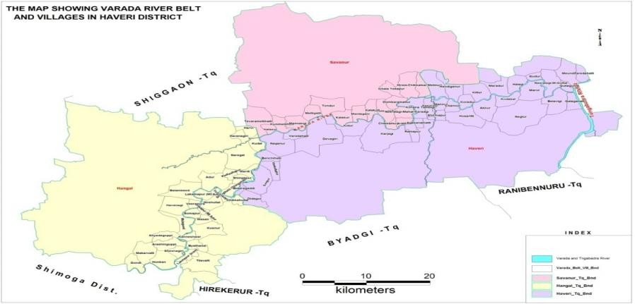

### Fig. No. 01: Map showing the Study area5

* Bank of Varada river consists of 64 villages with both dry and wet landscape.
* Format and data sheets for the documentation of folklore practices were prepared along with the consent letter.
* 33 folklore practitioners were documented for the identification of the plants, local name, parts used, method of preparation of the medicine, mode of administration, duration, and their parameters for the diagnosis of different diseases.
* Herbarium\ Photograph of selected species was documented. Specimen was identified with the aid of floras. 6,7
* Audiovisual medias were used during the documentation for the authenticity.

## Results and Discussion

* Towards fulfilling the objective of folklore documentation during the ethnobotonical study totally 33 folklore practitioners were interviewed and the data sheets were documented for their different folklore practices respectively. During this study it was found that totally 68 different plants belonging to 38 different families, 64 species and 63 genera are used in treating 34 different diseases . Among them 37 are herbs, 7 shrubs,

13 trees and 11 are trees.Most of the species from Mimosaceae family (14.8%), Euphibiaceae, Asteraceae, Solanaceae (11.11%), Acanthaceae, Amaranthaceae, Asclepiadaceae, (7.40%), the remaining families Apocynaceae, Aristolochiaceae, Cucurbitaceae, uphorbiaceae, Amaranthaceae, Urticaceae and Zygophyllaceae (3.70%).

* In most of the cases leaves were used predominantly (34.78%) for drug preparation followed by whole plant (30.43%), seeds (19.56%), Fruits (8.69%) and roots (6.52%).Among the drug formulations powder (67.88%), juice (21.42%) were frequently used, paste (10.71%) are less in use. Among them it was revealed that 19 therapeutic remedies are having classical references in Ayurveda like use of *Abrus precatorius Linn* in skin disorders, *Plumbago zeylanica Linn* in piles, *Mimosa pudica Linn* in uterine disorders, *Cissus quadrangularis Linn* in fractures etc and uses like leaf of *Sanseveria cylindrical Linn* in ear discharge, flower of *Spilanthus acmella Rox* in stomatitis, root of *Acalypha indica Linn* in paralysis etc, are anubhuta prayogas. (Practiced from ancestors)

# 138

Ashwini Vastrad. et al., Int. J. Pharm & Ind. Res., Vol.–05 (02) 2015 [136 - 140]

### Table No. 01: Showing folklore documentation of Haveri district (Bank of Varada river)

**Sl. No. Name of the plant Disease Useful part Mode of administration**

1. *Abutilon indicum Linn* Tenea pedis Root External application
2. *Sanseveria cylindrica Linn* Ear discharge and

pain

Leaf Juice extract of leaf is used as ear drops

1. *Spilanthus acmella Linn* Stomatitis, Cough Flower Chewing of flower with saliva
2. *Costus ingneus Linn* Madhumeha Leaf Chewing and swallowing of leaf
3. *Foeniculum vulgare Linn* Indigestion Fruit Sl No 5-7 are taken in equal quantity and

made fine powder and given orally

1. *Terminalia chebula Linn* Fruit
2. *Cassia angustifolia Linn* Leaf
3. *Aristolochia indica Linn* Septic conditions Root Root made into paste along with lime juice and

given orally

1. *Tinospora cordifolia Linn* Osteoarthritis

Leaf and stem

Sl No 9 &10 are taken in equal quantity and made into powder , added with equal quantity of juice of leafof Sl No 11 & given orally

1. *Swertia chirata Linn* Stem
2. *Aegel marmelos Linn* Leaf
3. *Cissus quandrangularis R* Fracture Stem Stem is used in the form of food.
4. *Withania somnifera Linn* Joint dislocation and

fracture

Root Powder is given orally

1. *Tinospora cordifolia Linn* Tooth ache and Gum

disorder

Leaf and stem

Sl No 14-17 are taken in equal quantity and made in to fine powder& used as tooth powder.

1. *Adothoda vasica Linn* --- Leaf
2. *Cassia auriculata Linn* --- Whole plant
3. *Eunequa sodium chloride* ---
4. *Acacia farnesiana Linn* Septic conditions Leaf Juice of leaf is given orally.
5. *Momordia charantia Linn* Ear pain and

discharge

Leaf Juice of leaf is used as ear drops.

1. *Acalypha indica Linn* Chronic wound Leaf Oil prepared with leaves of the plant is used

|  |  |  |  |
| --- | --- | --- | --- |
|  | | | externally. |
| 21. *Balanitis aegyptiaca Linn* | Epilepsy | Hole plant | Powder |
| 22. *Euphorbia hirta Linn* | Skin disorder | Hole plant | Oil prepared with this plant is used externally |

1. *Kirganelia reticulata Linn* Burning of feet Leaf Paste of the leaf is mixed with water and used for

foot bath.

1. *Costus speciosus Linn* Piles Kanda Extracted juice of rhizome is used orally.
2. *Leptadenia reticulata Linn* Common cold and

nasal block

Latex Latex is used in the form of nasya.

1. *Securnega leucopyrus Linn* Foreign body in the

eye

Leaf and stem

The juice obtained after cutting the stem is blown into the eyes.

1. *Securnega leucopyrus Linn* Diarrhoea Leaf and

stem

The paste of leaf is used orally in severe diarrhea.

1. *Semicarpus anacardium Linn*

Tenea pedis Fruit The juice obtained after its heating is applied

externally followed by ash.

1. *Souropes androgynis Linn* Diabetes mellitus Leaf Leaves are used in the form of food.
2. *Gymnema sylvestre Linn* Diabetes mellitus leaf Fresh leaves are taken orally
3. *Aegel marmelos Linn* Leucorrhoea Leaf Fresh juice of leaves is used orally
4. *Hollarrhena antidysentrica Linn*

Tooth ache and gum disorder

Leaf Leaves are chewed with saliva and swallowed.

1. *Andrographis paniculata Linn*

Purities Whole plant Powder of dried plant is used orally

* + The other folk remedies were documented like use of root paste of *Abutilon indicum Linn* in Tenea pedis, Laef of *Costus ingneus Linn* in Madhumeha, Root paste of *Aristolochia indica Linn* made with lime juice given orally in septic conditions, stem of *Cissus quandrangularis Linn* and powder of root of *Withania somnifera Linn* used orally in

fractures, the powder made with leaf of *Tinospora cordifolia Linn*, *Adothoda vasica Linn*, *Cassia auriculata Linn* added with *Eunequa sodium chloride* used in tooth ache and gum disorders, leaf juice of *Acacia farnesiana Linn* used orally in septic conditions, whole plant of *Mimosa pudica Linn* is used to treat piles and leucorrhoea,

Ashwini Vastrad. et al., Int. J. Pharm & Ind. Res., Vol.–05 (02) 2015 [136 - 140]

139

application of oil prepared with leaf of *Acalypha indica Linn* in chronic wound, oil of whole plant of *Euphorbia hirta Linn* used effectively in skin disorders, fruit juice of *Semicarpus anacardium Linn* in tenea pedis, leaf paste of *Securnega leucopyrus Linn* given orally with butter milk in diarrhea, daily use of leaves of *Souropes androgynis Linn* and *Gymnema sylvestre Linn* found effective in Diabetes mellitus, leaf juice of *Aegle marmelos Linn* and root powder of *Cassia tora Linn* with milk given orally are found effective in leucorrhoea, leaf of *Hollarrhena antidysentrica Linn* is chewed in tooth ache, leaf of *Achyranthus aspera Linn* used in neuritis, paste of leaf of *Gmelina arborea Linn* and *Asperagus racemosus Linn* given orally in fractures. The folk people also claim that use

of compound drug therapies are found more effective in chronic diseases.

* Reveal of popularity level (RPL) and fidelity level (FL) showed that among 68 different plants belonging to 38 different families, 64 species and 63 genera *Tinospora cordifolia Linn* ( Guduchi ), *Aegle marmelos Linn* ( Bilwa ), *Aristolochia indica Linn* (Eeshwari), *Hibiscus rosasinensis Linn*(Japa), *Asparagus racemosus Linn (*Shatavari), *Areva lanata Linn* (Pashanabheda) are more commonly and repeatedly used by the folklore practitioners in treating disorders like joints pain, tooth ache, leucorrhoea, abdominal disorders, renal calculi and septic conditions.Further research is needed to conserve and develop some selected species of folklore herbs and to preserve the knowledge of indigenous communities.

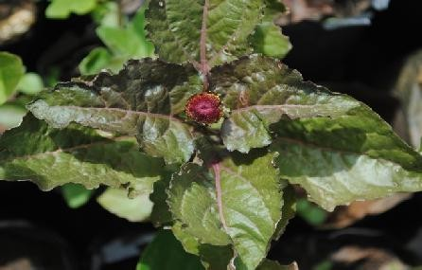 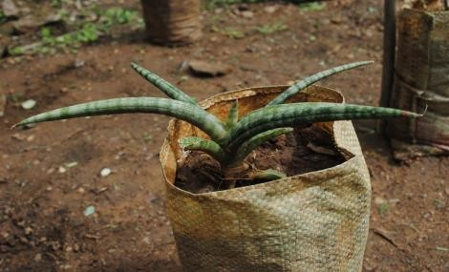

**Fig. No. 02: *Spilanthus acmella Linn* Fig. No. 03: *Sanseveria cylindrical Linn***

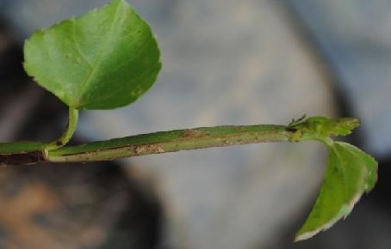

**Fig. No. 04: *Cissus quandrangularis Linn***

**References**

1. Bdsknowledge.org/dyn[homepage on the internet]. srilanka: Rienprecht enterprise culture,Inc.c2002-03 [updated 2004 july3; cited 2005 July 6]. Available from htpp // www.google.
2. Society of Ethnobiology's "What is Ethnobiology" webpage Accessed 12 April 2008 ALEXIADES, M.N. (1996) *Selected guidelines for ethnobotanical research: a field manual.* The New York Botanical Garden. New York.

# 140

Ashwini Vastrad. et al., Int. J. Pharm & Ind. Res., Vol.–05 (02) 2015 [136 - 140]

1. Ambalaki hiriyanna, Krishnegouda TS as author: Govt of Karnataka, editors. Gazetteer of Dharwad district, Karnataka: Dharwad

;1997. pp. 8-37.

1. Bhadra wild life sanctuary in Karnataka, Indian journal of tradition knowledge, 3(1):37- 50.
2. Ambalaki hiriyanna, Krishnegouda TS as author: Govt of Karnataka, editors. Gazetteer

of Dharwad district. Karnataka: Dharwad

;1997.pp.15

1. Saldanha, C.J. 1984. Flora of Karnataka. vol. I, Oxford & IBH Publishing, Co. Pvt. Ltd, New Delhi.
2. Saldanha, C.J. 1996. Flora of Karnataka. vol. II, Oxford & IBH Publishing, Co. Pvt. Ltd, New Delhi.