***Research Article***

**Available Online at:** [**www.ijpir.com**](http://www.ijpir.com/)



International Journal of Pharmacy and Industrial Research

**ISSN**

**Print 2231 – 3648**

**Online 2231 – 3656**

**PREPARATION AND IN VITRO EVALUATION OF BUCLIZINE ORAL THIN FILM STRIPS**

# *1Vijaya Kuchana, 1Deepthi Kammila, 2Sunitha Sampathi, 3Pamu Sandhya, 1Amareshwar S

1R.G.R. Siddhanthi College of Pharmacy, Secunderabad - 500 003, A.P, India.

2National Institute of Pharmaceutical Education and Research, Hyderabad - 500 037, A.P, India.

3Shadan Womens College of Pharmacy, Khairatabad, Hyderabad - 500 004, A.P, India.

**Abstract**

Buclizine is an antihistaminic water soluble drug. The objective of the present investigation was to improve bioavailablity of buclizine oral thin film strips by using solvent casting method with excipients. Water soluble synthetic polymer (Poly Vinyl Alcohol), plasticizer (PVP), solubilizer (PEG400), carbapol, sweetener (Mannitol) was used in the preparation of oral thin film strips of buclizine. The oral thin films of buclizine were prepared by solvent casting method using 1:1 and 1:2 ratios of drug and polymers. The influence of the proportion of polymer and several co-excipients on the release rate of the drug from formulations was studied.

**Keywords:** Antihistaminic, Buclizine, Oral thin film strips.

## Introduction

Thin-film drug delivery uses a dissolving film or oral drug strip to administer drugs via absorption in the mouth (buccally or sublingually) and/or via the small intestines (enterically). A film is prepared using hydrophilic polymers that rapidly dissolves on the tongue or buccal cavity, delivering the drug to the systemic circulation via dissolution when contact with liquid is made. Oral films, also called oral wafers in the related literature, are a group of flat films which are administered into the oral cavity1.

### Buclizine

Buclizine is an antihistamine and anticholinergic of the piperazine derivative family. It is considered to be an antiemetic4.

### Thin-film drug delivery

Thin-film drug delivery uses a dissolving film or oral drug strip to administer drugs via absorption in the mouth (buccally or sublingually) and/or via the small intestines (enterically). A film is prepared using hydrophilic polymers that rapidly dissolves on the tongue or buccal cavity, delivering the drug to the systemic circulation via dissolution when contact with liquid is made5.

Thin-film drug delivery has emerged as an advanced alternative to the traditional tablets, capsules and liquids often associated with prescription and OTC medications. Similar in size, shape and thickness to a postage stamp, thin-film strips are typically designed for oral administration,

### Author for Correspondence:

Vijaya Kuchana,

R.G.R. Siddhanthi College of Pharmacy, Secunderabad - 500 003, A.P, India.

E-mail: [drvijayakuchana@gmail.com](mailto:drvijayakuchana@gmail.com)

with the user placing the strip on or under the tongue (sublingual) or along the inside of the cheek (buccal). These drug delivery options allow the medication to bypass the first pass metabolism thereby making the medication more bioavailable. As the strip dissolves, the drug can enter the blood stream enterically, buccally or sublingually. Evaluating the systemic transmucosal drug delivery, the buccal mucosa is the preferred region as compared to the sublingual mucosa2, 6.

### Oral drug strip development Strip forming polymers

The polymer employed should be non-toxic, non- irritant and devoid of leachable impurities. It should have good wetting and spreadability property. The polymer should exhibit sufficient peel, shear and tensile strengths. The polymer should be readily available and should not be very expensive. Film obtained should be tough enough so that there won't be any damage while handling or during transportation. Combination of microcrystalline cellulose and maltodextrin has been used to formulate Oral Strips of piroxicam made by hot melt extrusion technique. Pullulan has been the most widely used film former (used in Listerine PocketPak, Benadryl, etc.)

### Plasticizer

Plasticizer is a vital ingredient of the OS formulation. It helps to improve the flexibility of the strip and reduces the brittleness of the strip. Plasticizer significantly improves the strip properties by reducing the glass transition temperature of the polymer. Glycerol, Propylene glycol, low molecular weight polyethylene glycols, phthalate derivatives like dimethyl, diethyl and dibutylphthalate, Citrate derivatives such as tributyl, triethyl, acetyl citrate, triacetin and castor oil are some of the commonly used plasticizer excipients.

### Active pharmaceutical ingredient

Since the size of the dosage form has limitation, high-dose molecules are difficult to be incorporated

in OS. Generally 5% w/w to 30% w/w of active pharmaceutical ingredients can be incorporated in the OS3.

### Sweetening, flavouring and colouring agent

An important aspect of thin film drug technology is its taste and colour. The sweet taste in formulation is more important in case of pediatric population. Natural sweeteners as well as artificial sweeteners are used to improve the flavour of the mouth dissolving formulations for the flavours changes from individual to individual. A pigment such as titaniumdioxide is incorporated for colouring.

### Stabilizing and thickening agents

The stabilizing and thickening agents are employed to improve the viscosity and consistency of dispersion or solution of the strip preparation solution or suspension before casting. Drug content uniformity is a requirement for all dosage forms, particularly those containing low dose highly potent drugs. To uniquely meet this requirement, thin film formulations contain uniform dispersions of drug throughout the whole manufacturing process9.

Approaches used for the formulation of oral thin films

* Conventional approaches
* Solvent casting method
* Hot-melt extrusion
* Semisolid casting

### Solvent casting method13

In this method, firstly the water soluble polymers are dissolved in water at 1,000 rpm and can be heated up to 60°C. All the other excipients like colors, flavoring agent, sweetening agent, etc., are dissolved separately. Then both the solutions obtained are mixed thoroughly stirring at 1,000 rpm. The obtained solution is incorporated with the API dissolved in suitable solvent. The entrapped air is removed by vacuum. The resulting solution is cast as a film and allowed to dry, which is then cut into pieces of the desired size11.

## Materials & methods

### Composition of buclizine oral thin film strips

**Table No. 01: Formulation design of Buclizine oral thin film strips**

|  |  |  |  |  |  |  |
| --- | --- | --- | --- | --- | --- | --- |
| **Ingredients** | **B1** | **B2** | **B3** | **B4** | **B5** | **B6** |
| Buclizine (mg) | 4 | 4 | 4 | 4 | 4 | 4 |
| PVA | 4 | 8 | 12 | 4 | 8 | 12 |
| PVP | 23 | 58 | 23 | 58 | 23 | 58 |
| PEG 400 | 4 | 8 | 12 | 4 | 8 | 12 |
| Carbapol | 32 | 16 | 8 | 32 | 16 | 8 |
| Mannitol | 16 | 16 | 16 | 16 | 16 | 16 |
| Strip weight | 98mg | 98mg | 98mg | 98mg | 98mg | 98mg |

### Preparation of buclizine oral thin film strips by using solvent casting method

**Aqueous solution 1:**

Dissolved (PVA) polymer in 20 ml hot water with stirring to produce a clear solution and kept for 2 hr to remove air bubbles14. Carbapol 934P was first dissolved in water, neutralized with diethanolamine and then added to the cooled PVA solution.

### Aqueous solution 2:

Dissolved pure drug, sweetener and plasticizer (PVP) in specified proportion of distilled water.

Aqueous solution 1 was mixed with aqueous solution 2 and stirred for 1 hr. The solution was cast on to 9 cm diameter petridish and was dried in the oven at 450c for 24 hr. The films were carefully removed from the petridish and checked for any imperfection and cut accurately to square films of 2 cm length, 2 cm width so that each film contained 4 mg of the drug the samples were stored in glass container maintained at temperature 300c and relative humidity 60% ± 5%until further analysis7,

15.

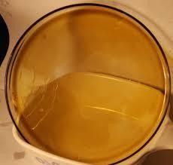

### Fig. No. 01: Buclizine Oral Thin Film Strip

**Evaluation of oral thin film formulations Tensile Strength**

Tensile strength of the film was determined with digital tensile tester, which consists of two load cell grips. The lower one is fixed and the upper one is movable. The test film was placed between these

two cell grips and force was gradually applied till the film breaks. It is calculated by formula

Tensile strength = force at break/ initial cross sectional area of film in mm2

### Percentage Elongation

The percentage elongation was carried out using Hounsfield universal testing machine. It consists of two load cell grips. The lower is fixed and upper is movable. The test film of specific 3inch x 10mm was fixed between these two cell grips and force was gradually applied till the film breaks. It is calculated by formula

% Elongation = increase in length * 100

Original length

### Folding Endurance

The flexibility of films can be measured quantitatively in terms of Folding Endurance. Folding Endurance of the films was determined by repeatedly folding a small strip of the films (approximately 2x2cm) at the same place till it broke or visible cracks were observed. The number of times films could be folded at the same place, without breaking gives the value of folding endurance.

### In vitro Disintegration Time

In vitro disintegration time is determined visually in a glass dish of 25ml distilled water with swirling every 10sec. The disintegration time is the time is the time when the film starts to break or disintegrates10.

### In vitro Dissolution Studies

The in vitro dissolution studies is carried out in simulated saliva solution pH 6.4 phosphate buffer using USP type-II paddle apparatus at 37±0.5ºC. Samples are withdrawn at regular time interval and analyzed by UV-Visible spectrophotometer at 230 nm8, 12.

## Results & discussion

### Wavelength detection of Buclizine in phosphate buffer pH 6.4

**Table No. 02: Wavelength detection of Buclizine in phosphate buffer pH 6.4**

|  |  |
| --- | --- |
| **Wavelength** | **Absorbance** |
| 220 | 0.234 |
| 230 | 0.253 |
| 240 | 0.248 |
| 250 | 0.237 |
| 260 | 0.214 |
| 280 | 0.197 |
| 300 | 0.172 |
| 320 | 0.157 |
| 340 | 0.131 |
| 360 | 0.124 |
| 380 | 0.104 |

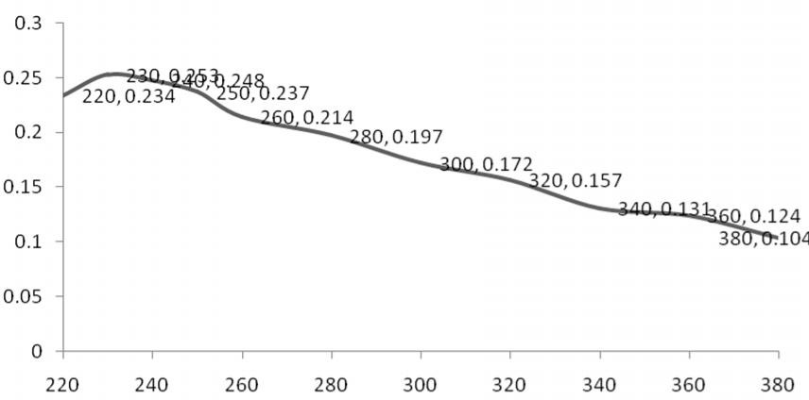

### Fig. No. 02: wavelength detection of Buclizine in phosphate buffer pH 6.4

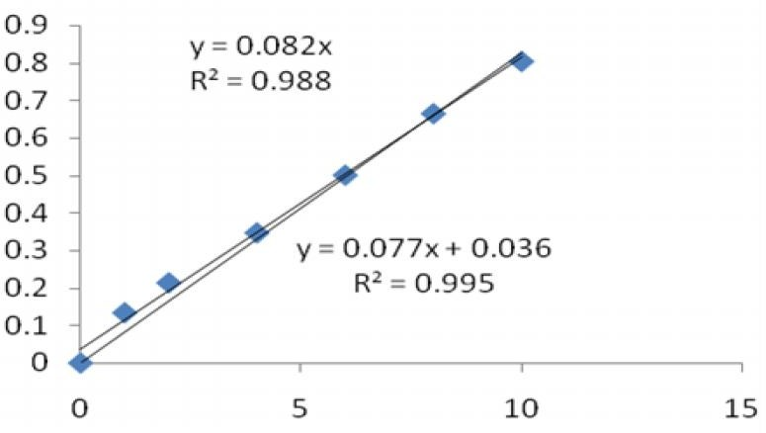**Construction of Calibration graph in 900ml phosphate buffer,ph 6.4: (λmax=230 nm)**

### Fig. No. 03: Calibration graph of buclizine using 6.4 phosphate buffer

**Calibration graph of buclizine using 6.4 phosphate buffer**

### Table No. 03: Calibration graph of buclizine using 6.4 phosphate buffer

|  |  |
| --- | --- |
| Concentration | Absorbance |
| µg/ ml | Trial 1 |
| 0 | 0 |
| 1 | 0.134 |
| 2 | 0.214 |
| 4 | 0.347 |
| 6 | 0.501 |
| 8 | 0.665 |
| 10 | 0.804 |

**Physical Evaluation of Thin film strips**

### Table No. 04: Physical Evaluation of Thin film strips

|  |  |  |  |  |  |
| --- | --- | --- | --- | --- | --- |
| **S. No** | **Formulations** | **\*Tensile strength** | **\*Percentage elongation** | **\*Folding *\*In-vitro***  **endurance disintegration time(sec)** | |
|  |  |  |  | **(no. of folds)** |  |
| **1** | **B1** | 2.07±0.82 | 24.19±0.21 | 85.05±0.031 | 21.44±1.21 |
| **2** | **B2** | 2.42±0.02 | 20.18±0.13 | 89.14±0.110 | 17.86±1.57 |
| **3** | **B3** | 3.12±0.05 | 26.11±0.51 | 86.33±0.024 | 14.05±1.42 |
| **4** | **B4** | 1.54±0.04 | 18.16±0.07 | 92.24±0.022 | 21.26±0.81 |
| **5** | **B5** | 2.24±0.04 | 22.32±0.31 | 94.07±0.036 | 19.50±0.52 |
| **6** | **B6** | 3.05±0.03 | 19.05±0.11 | 96.03±0.016 | 16.42±1.05 |

**Percentage Cumulative drug release of films B-1 to B-6**

### Table No. 05: Percentage Cumulative drug release of films B-1 to B-6

|  |  |  |  |  |  |  |
| --- | --- | --- | --- | --- | --- | --- |
| **Time in SEC's** | **B1** | **B2** | **B3** | **B4** | **B5** | **B6** |
| 0 | 0.00 | 0.00 | 0.00 | 0.00 | 0.00 | 0.00 |
| 30 | 16.64 | 25.13 | 20.04 | 26.66 | 24.96 | 33.45 |
| 60 | 31.51 | 40.70 | 34.75 | 55.21 | 56.13 | 65.16 |
| 90 | 42.21 | 66.90 | 60.93 | 78.77 | 76.29 | **100.15** |
| **120** | **59.08** | **80.28** | **76.38** | **99.92** | **94.37** | **100.18** |

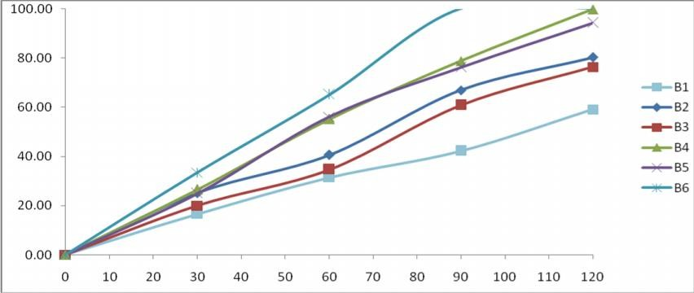

**Fig. No. 04: Percentage Cumulative drug release of films B1 to B6 (Time on x-axis and % drug release on y-axis)**

## Summary and conclusion

The fast dissolving films containing Buclizine were prepared with an aim to have rapid onset of action and increased bioavailability in allergic conditions. Various cellulose derivatives were employed for

their film forming properties of which PEG and PVA showed promising physicochemical properties as compare to all other grades therefore, it was selected for further studies. Prepared films were transparent with smooth surface and

acceptable mechanical properties. It can be concluded that Oral thin strip of Buclizine can be prepared using the polymer combinations of B4 and B5. Depending on physical evaluation and drug release it was concluded that B4 is optimized among all the formulations.

## References

1. Kunte S, Tandale P. Fast dissolving strips: A novel approach for the delivery of verapamil. J Pharm Bioall Sci.2010; 4: 325-328. 1. Alpesh R.P., S.P. Dharendra, A.R. Jignyasha (2010).
2. Fast Dissolving Films: A Newer Venture in Fast Dissolving Dosage Forms, Int.J.Drug Dev. & Res 2: 232-246.
3. TCI. (2008) Oral Thin Films, Orally disintegrating tablet and film technologies, Technology Catalysts International (TCI), Falls Church.
4. Tripathi KD, (2008) Essential of Medical Pharmacology, 7th ed, Jaypee Publisher Ltd. Delhi: 639.
5. Vishwkarma DK, Tripathi AK, Yogesh P, Maddheshiya B. Review article on mouth dissolving film. J Global Pharm Tech.2011; 3(1):1-8.
6. Parmar RB, Baria AH, Tank HM, Faldu SD. Formulation and evaluation of domperidone Fast Dissolving Tablets. Int J Pharm Tech

Res. 2009;1(3):483-487.

1. Dhagla Ram Choudhary, Vishnu A Patel, Usmangani Chhalotiya1, Harsha V Patel, Aliasgar J Kundawala.Formulation and evaluation of fast Dissolving Film of levocetirizine dihydrochloride using different grades of methocel. J Pharm Res.2011; 4(9): 2919-2924.
2. Aditya Dinge, Mangal Nagarsenke. Formulation and evaluation of fast dissolving films for delivery of triclosan to the oral cavity. AAPS Pharm Sci Tech. 2008; 9(2):349- 356.
3. Kunte S, Tandale P. Fast dissolving strips: A novel approach for the delivery of verapamil. J Pharm Bioall Sci. 2010; 4: 325-328.
4. Koland M, Sandeep VP, Charyulu NR. Fast dissolving sublingual films of ondansetron hydrochloride: Effect of additives on *in- vitro* drug release and mucosal permeation. J Young Pharmacists. 2010; 2(3): 216-22.
5. Shimoda H *et al*. Preparation of a fast dissolving oral thin film containing dexamethasone: A possible application to antiemesis during cancer chemotherapy. Eur J Pharm Biopharm. 2009; 73: 361-365.
6. Attama AA, Akpa PA, Onugwu LE, Igwilo G. Novel buccoadhesive delivery system of hydrochlorothiazide formulated with ethyl cellulose and hydroxypropyl methyl cellulose interpolymer complex. Sci Res Essay.2008; 3(6): 343-347.
7. Weinberger M. Pharmacological management of asthma. J Adolescent Health Care 1987; 8(1):74-83.
8. Nafee NA, Boraie NA, Ismail FA, Mortada LM. Design and characterization of mucoadhesive buccal patches containing Cetylpyridinium chloride. Acta Pharm 2003; 53:199-212.
9. Mashru RC, Sutariya VB, Sankalia MG, Parikh PP. Development and evaluation of fast dissolving film of salbutamol sulphate. Drug Dev Ind Pharm 2005; 31:25-34.